FOR WRITTEN REPLY

NATIONAL ASSEMBLY
36/1/4/1(201900041)

QUESTION 334

DATE OF PUBLICATION IN INTERNAL QUESTION PAPER: 22 FEBRUARY 2019 (INTERNAL QUESTION PAPER NO 3-2019)

334. Ms N V Mente (EFF) to ask the Minister of Police:

- Whether he has been informed that Constable N I Chabaesele (details furnished) was attacked by a dog while on duty; if so, (a) what amount in compensation was paid to the Constable, (b) was transport provided for follow-up appointments to the doctor and (c) was trauma and counselling support provided;

- was the Constable given full leave while she was off as a result of the attack; if not, what is the position in this regard; if so, what are the further relevant details?
NW356E
REPLY:

- Yes.
(1)(a) An injury board was submitted. No feedback has been received from the Workman's Compensation Commissioner, yet.
(1)(b) Yes, transport was provided.
(1)(c) No trauma counselling was requested.
- Yes, temporary incapacity leave was granted.

Reply to question 334 recommended/

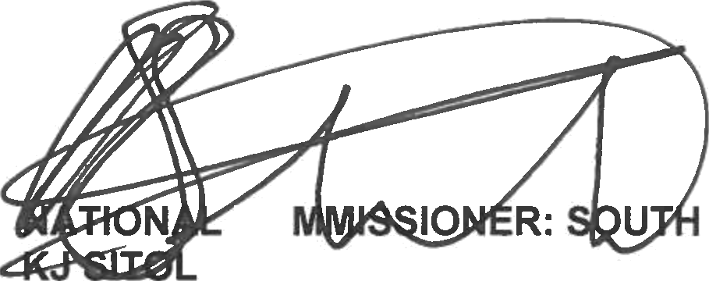
GENERAL AFRICAN POLICE SERVICE

CO
E (SOEG)

Date: y19 -»- ››

2

Reply to question 334 approved/not approved

MINISTER OF POLICE BH CELE, MP

Date:

