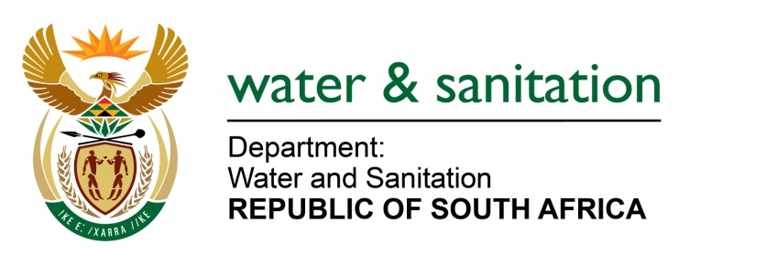

NATIONAL ASSEMBLY

FOR WRITTEN REPLY

QUESTION NO 3332

DATE OF PUBLICATION IN INTERNAL QUESTION PAPER: 4 SEPTEMBER 2015
(INTERNAL QUESTION PAPER NO. 35)

3332. Ms C N Majeke (UDM) to ask the Minister of Water and Sanitation:
Whether, with reference to the debilitating sewerage system in Qumbu in the Eastern Cape, she has a plan in place to intervene in assisting and building capacity in both the OR Tambo District Municipality and the Mhlontlo Local Municipality in the Eastern Cape so that flush toilets with septic tanks are constructed in order to replace the pit latrine toilets that are debilitating and creating a health hazard to the people of Qumbu? NW3933E
---00O00---
REPLY:
The OR Tambo District Municipality has a capacity in the form of a Technical Director and fully fledged Project Management Unit and there is a plan in place to upgrade sanitation services in the Qumbu town. The OR Tambo District Municipality is in the initial phase of appointing a professional service provider that will prepare a business plan and a technical report to ensure that there is a full waterborne sewerage system that will replace the existing septic tanks and pit latrines in Qumbu Town.
---00O00---

