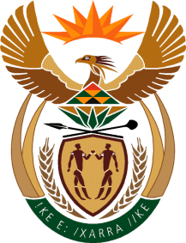

MINISTRY OF TOURISM
REPUBLIC OF SOUTH AFRICA

Private Bag X424, Pretoria, 0001, South Africa. Tel. (+27 12) 444 6780, Fax (+27 12) 444 7027
Private Bag X9154, Cape Town, 8000, South Africa. Tel. (+27 21) 469 5800, Fax: (+27 21) 465 3216

Ref: TM 2/1/1/10

NATIONAL ASSEMBLY:
QUESTION FOR WRITTEN REPLY:
Question Number: 3329
Date of Publication: 27 October 2017
NA IQP Number: 39
Date of reply: 13 November 2017
Mr T Rawula (EFF) to ask the Minister of Tourism:
- Whether the (a) chief executive officer and (b) chief financial officer of entities reporting to her are employed on a permanent basis; if not,

- The Chief Executive Officer of SA Tourism is not employed on a permanent basis.
- The Chief Financial Officer of SA Tourism is not employed on a permanent basis.
(2) Whether the specified officers are employed on a fixed term contract; if so, (a) what are the names of each of the officers and (b) when (i) was each officer employed and (ii) will each officer’s contract end? NW3718E
Reply
- (a) The Chief Executive Officer of SA Tourism is not employed on a permanent basis.

(b)The Chief Financial Officer of SA Tourism is not employed on a permanent basis.

(2) Both the specified officers are employed on fixed term contracts.
- Name of Officer | (b) (i) When was Officer employed | (b) (ii) When will contract of Officer end?
Mr. Sisa Ntshona  CEO | 03 October 2016 | 30 September 2021
Mr. Thomas Bouwer CFO | 17 October 2013 | 30 October 2018

