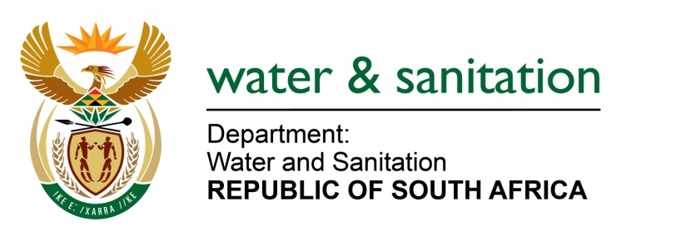

NATIONAL ASSEMBLY

FOR WRITTEN REPLY

QUESTION NO 3328

DATE OF PUBLICATION IN INTERNAL QUESTION PAPER: 23 SEPTEMBER 2022
(INTERNAL QUESTION PAPER NO. 36)

3328. Ms A M van Zyl (DA) to ask the Minister of Water and Sanitation:
(a) What number of (i) wastewater treatment plants and (ii) pump stations connected and feeding to the wastewater treatment plants are functional in the (aa) Walter Sisulu Local Municipality and (bb) Senqu Local Municipality, (b) for those that are not working, what are the reasons that they are not working and (c) what plans has his department put in place in order to address the challenges?
NW4133E
---00O00---

MINISTER OF WATER AND SANITATION

- The Joe Gqabi District Municipality (JGDM) operates twelve (12) Waste Water Treatment Works (WWTW) in the Walter Sisulu and Senqu Local Municipalities. The status of the WWTW and pump stations is as follows:

- Details regarding the state of the WWTW:
- In the Walter Sisulu LM, there are six (6) wastewater treatment plants of which five (5) are functional and one (1) is non-functional
- In the Senqu LM, there are six (6) wastewater treatment plants, five (5) are functional and one is non-functional.

- Details regarding the state of the Pump Stations:
- In the Walter Sisulu LM, there are eight (8) pumpstations, four (4) are funtional and the other four (4) are non-functional
- In the Senqu LM, there are five (5) pumpstations that are all functional.

- Reasons for failures of the WWTW were mostly due to mechanical and electrical failures as well as theft and vandalism of electrical equipment and cables, particularly at pump stations in the Walter Sisulu LM.

- Funding has been availed from various sources; including the District Municipality’s internal funds, Water Services Infrastructure Grant and Regional Bulk Infrastructure Grant from Department of Water and Sanitation; to facilitate the repairs of the non-functional plants. Progress is as follows:
- New pumps have been purchased by the Walter Sisulu LM to replace the non-functional pumps
- Repairs were recently completed to WWTWs in at Oviston, Venterstad in the Walter Sisulu LM and and Herschel in the Senqu LM
- A contractor to refurbish the Steynsburg WWTW in the Walter Sisulu LM has been appointed and is already on site
- Project plans are awaiting approval for the refurbishment of the Sterkspruit WWTW in the Senqu municipality
- The Joe Gqabi DM has responded well to the notices and directives issued by the Department of Water and Sanitation (DWS) and will be reprioritising the WSIG funds to address the challenges

---00O00---

