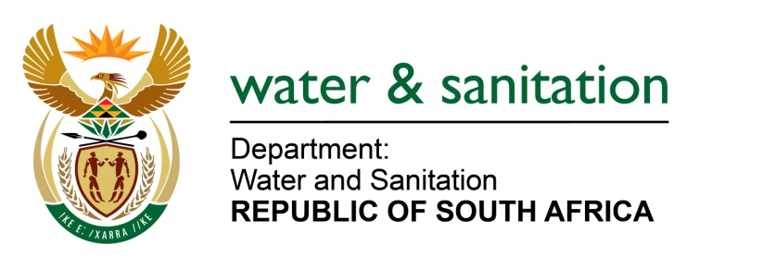

NATIONAL ASSEMBLY

FOR WRITTEN REPLY

QUESTION NO 3324

DATE OF PUBLICATION IN INTERNAL QUESTION PAPER: 27OCTOBER 2017
(INTERNAL QUESTION PAPER NO. 39)
3324. Ms M S Khawula(EFF) to ask the Minister of Water and Sanitation:
(1) Whether the (a) chief executive officer and (b) chief financial officer of entities reporting to her are employed on a permanent basis; if not,
(2) whether the specified officers are employed on a fixed term contract; if so, (a) what are the names of each of the officers and (b) when (i) was each officer employed and (ii) will each officer’s contract end? NW3712E
---00O00---
REPLY:

(ii) Entity | (1)Whether the  (a) chief executive officer of entities reporting to her are employed on a permanent basis,if not, | (b) chief financial officer of entities reporting to her are employed on a permanent basis,if not, | (2)whether the specified officers are employed on a fixed term contract; if so,  (a)what are the names of each of the officers | (b)when
 |  |  |  | (i) was each officer employed | (ii) will each officer’s contract end
Amatola Water | Fixed-term contract basis | Fixed-term contract basis | Ms. Asanda Gidana (Acting CEO) | CEO was appointed on an acting capacity as of 1 August 2017 | until further notice
 |  |  | Ms. Kwandiwe Mviko(Acting CFO) | CFO was appointed on an acting capacity as of 21 August 2017 | until further notice
Bloem Water | Fixed-term contract basis | Permanent | Dr L Moorosi | CEO was appointed on 15 April 2013 | Yes, Contract will end 30 April 2018
 |  |  | Mr. OJ Stadler | CFO was appointed in October 1995 | No, Contract is indefinite
Lepelle Northern Water | Fixed-term contract basis | Fixed-term contract basis | Mr. Phineas Legodi (CEO) | CEO was appointed on 1 January 2017 | Yes, Contract will end 31December 2021
 |  |  | Ms. Sibongile Valoyi (Acting CFO) | CFO was appointed to act as of 1 August 2017 | until further notice
Magalies Water |  |  | Mr Sandile Mkhize | CEO was appointed to act as of 9 September 2016. | until further notice
 |  |  | Ms K. Kgatuke, | Resigned on the 31 August 2017 | Recruitment for the new CFO is currently in progress
Mhlathuze Water | Fixed term contract | Fixed term contract | Mr. Mthokozisi Pius Duze (aCEO) | 8 June 2016 | until further notice
 |  |  | Mr. Brian Ndaba (CFO) | 1 November 2012 | 31 October 2018
Overberg Water | Fixed-term contract basis | Permanent | Mr Phakamani Buthelezi (acting CEO) | July 2017 Secondment | Undetermined
 |  |  | CFO post is put on an acting basis due to an administrative process. | CFO post is put on an acting basis due to an administrative process. | CFO post is put on an acting basis due to an administrative process.
Rand Water | Fixed term contract | Fixed term contract | Mr Dinizulu Kumalo Percival Sechemane (CEO) | 1 September 2013 | 31 August 2018
 |  |  | Ms Matshidiso Sylvia Nyembe (CFO) | 18 May 2014 | 17 May 2019
Sedibeng Water | Fixed-term contract basis | Permanent | Mr. Rembuluwani Tradewin Takalani (CEO) | CEO was appointed on 20 May 2014 | Yes, Contract will end on 30 June 2019
 |  |  | Ms. Mpinane Shasha (CFO) | CFO was appointed on 1 February 2015 | No, Contract is indefinite
Umgeni Water | Fixed term contract | Fixed term contract | Mr Thami Hlongwa (aCEO) | 01 July 2013 | 30 June 2018
 |  |  | Mr Thami Hlongwa (CFO) | 01 July 2013 | 30 June 2018
TCTA | Fixed-term contract basis | Fixed-term contract basis | Mr. NL Radzuma (Acting CE) | Acting CEO was appointed on 1 November 2016 | February 2018, where after Mr. Radzuma will revert to his role as Chief Risk Officer (CRO)
 |  |  | Ms. H Nazeer (CFO) | CFO was appointed on 1 September 2016 | Yes, Contract ends 31 August 2019
WRC | Fixed term contract | Permanent basis | Mr Dhesigen Naidoo | 01 October 2011 | 30 September 2021

---00O00---

