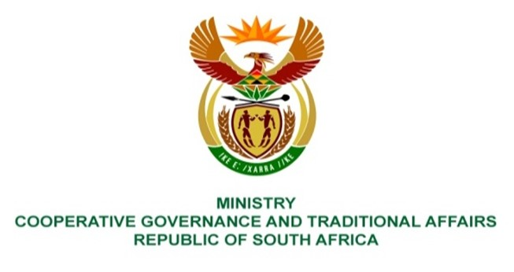

NATIONAL ASSEMBLY
QUESTION FOR WRITTEN REPLY

QUESTION NUMBER 332
DATE OF PUBLICATION: 17 FEBRUARY 2023

332. Mr T Mogale (EFF) to ask the Minister of Cooperative Governance and Traditional Affairs:
What disaster measures of intervention have been taken to prevent further flooding in affected areas? NW347E

REPLY:
The department through the National Disaster Management Centre (NDMC) is coordinating and collaborating with relevant stakeholders focusing on emergency preparedness to enable a state of readiness by relevant organs of state in anticipation of disasters. In case of the floods, the following key intervention measures were taken by my department:
- Collaboration with the South African Weather Service (SAWS) in the further dissemination of early-warnings and advisories to relevant organs of state, stakeholders and organs of state for informed decision-making as well as ensuring that further damages and losses are avoided where possible;
- Activation of the National Joint Floods Coordination Committee (NJFCC) as well as facilitate activations of relevant structures across the spheres of government for the coordination of collaborative efforts by all relevant stakeholders regarding response and recovery efforts in affected provinces;
- FacilitateS the deployment of search and rescue teams from the Security Cluster for search and rescue missions in support of the affected provinces;
- Technical support to municipalities through the Municipal Infrastructure Agent (MISA) in addressing some of the critical infrastructure;
- Coordinate relevant national organs of state to mobilise resources and support to respective counterparts through existing sectoral arrangements and programmes;
- Ongoing monitoring of the conditions on the ground and providing support where required to prevent the situation from deteriorating further;
- Classification of the occurrence as a national disaster by the NDMC as per Section 23 of the Disaster Management Act, 57 of 2022 (DMA). This was with the primary objective of strengthening the coordination and management of the occurrence as well as the mobilisation of resources for intervention measures.
- Declaration of a national state of disaster by the Minister of CoGTA as per Section 27 of the DMA. This was mainly to augment existing legislation and contingency arrangements of the affected organs of state as well as activate other extraordinary measures as and when required.
- Facilitated the development of Seasonal Contingency Plan for the Summer Season by organs of state to deal with seasonal climate and weather-related events based on the Weather Outlook issued by SAWS. The NDMC further developed the National Seasonal Contingency Plan for the Summer Season outlining the preparedness/readiness measures by respective organs of state to deal with flooding eventualities during the Summer Season.
- Furthermore, the National Seasonal Contingency Plan for the Summer Season provides details of the preparedness and response procedures and activation protocols to be followed at national level to respond to disasters.
End.

