FOR WRITTEN REPLY

QUESTION 3305

NATIONAL ASSEMBLY
36/1/4/1(2018)

DATE OF PUBLICATION IN INTERNAL QUESTION PAPER: 2 NOVEMBER 2018 (INTERNAL QUESTION PAPER NO 37-2018)

3305. Mr L G Mokoena (EFF) to ask the Minister of Police:

- (a) On what date was the information technology (IT) Infrastructure of his (i) department and (ii) entities reporting to him last upgraded or updated, (b) what is the name of the companv contracted to do the upgrades, (c) what was the monetary value of the contract and (d) what is the name of each IT system that was upgraded;

- (a) what is the name of the company that is currently responsible for the maintenance of the IT systems of (i) his department and (ii) entities reporting to him and (b) what is the value of the contract?
NW3739E

REPLY:
The information provided is for the 2017/2018 financial year:
IT systerri maintained

Automatic Fingerprint Identification S stem AFISg Automated Balllstic Identification System (ABIS)
Contracted com an
Morpho Pty
Monetary value of contract

R

23 095 159,00

Forensic Technology
R
82 586 374.64
[3 year Contact value]
R 27 223 730,26
Ballistic Interface Unit (BIU)
. . - —
.
Shosho Industnal Supplies CC
—-— ——. -
nan—c—ia—lye—ar 20-17/1—8a
R R11 315 811.76
[3 year Contact value]
R 2 308 479.46
[financilaear 2017/18]

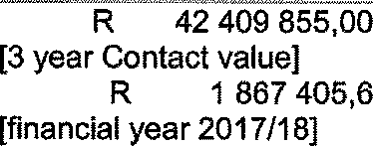
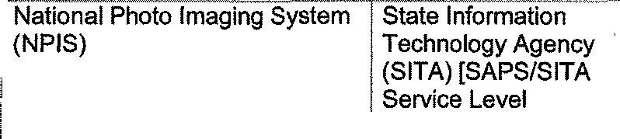
r
National Forensic DNA
Database (NFDD)
Agreement (SLA) 2017/2018} SAPS/SITA SLA 2017/2016
R
R3 445 0557,92
Property Control and Exhibit
Management (PCEM)
Forensic Data
Analysis (Pty) Ltd
R
98 123 160.02
[2 year Contact value]
R
20 400 188.00 '
[financial year 2017/18]
R 28 341 536.00
[invoiced but, not paid
the 2017/18 financial year]

i LabWare Biology
LabWare Africa
(Pty) Ltd
LabWare Scientific Analyses unit (SAU)
LabWare Africa (Pty) Ltd
R
1 701 050,1

STRLAB
SAPS/SITA SLA
2017/2018
R ”5 741 037”48'

. ....-.. . ..-......... ... ..,....,. -.„ .. . .. ....... .....
Decentralisation of the Criminal SAPS/SITA SLA
Record Information 2017/2018 Management (CRIM) system
. . - -- - --— —
Local Cnminal Record Centre SAPS/SATA SLA
Administration & Case 2017/2018 Information Management
system (LCRC)/CIMS)

Forensic Service SAPS/SITA SLA
! Laboratory(FSL) Admin System 2017/2018

R 7 606 416,00!

R 3 183 583,00

R 8 582 037,48

Commercial Explosives System SAPS/SITA SLA R 2 779 306,00 (CES)/ Bomb Disposal System 2017/2018

(ozs
!
Inkwazi System | SAPS/SITA SLA  2017/2018 | R ” | 2 783 225,64'
)Profling System (PROF) ” | SAPS/SITA SLA 2017/2018 | R | 1 164 581,28
)! Animal Identification Sysem”  (AIS} | SAPS/SITA SLA  2017/2018 | R | 590 363,28

D amond and Gold System (D&G)
. ....... .. ... . .......-..-..-.
I
Organised Crime Threat Management System (OCTMS) |  | SAPS/SITA SLA 2017/2018 | R | 1 518 995,88
investigation Case Docket Management System (ICDMS) |  | SAPS/SITA SLA 2017/2018 | R | 13 643 872,32’I
EnhancedFi”rearms Register  ystem (EFRS) |  |  | R | 13 667 563,33
 |  | SAPS/SITA SLA  2017/2018 | R | 11 947 489,83
Second Hand Goods System  (SHG) |  | SAPS/SITA SLA 2017/2018 | R | 4 184 834,25
OperatiDnal Planning and Monitoring System (OPAM) |  | SAPS/SITA SLA 2017/2018
!”Automated Vehicle Location (AVL) & Software license |  | C-Track |  | R 37 594 748,00
(Services includes:Vodacom Sim-Cards, AVL Software License, GEMC3 Software License, AVL Maintenance, VMU De-installation, VMU Refurbishments, VMU Re- installation, VMU Repairs
Emergency Response System (ERS) [GEMC3 System |  | TA SLA | R | 2 902 488,00
Business Intelligence (BI) / |  | SAPS/SITA SLA | R | 7 974819,00
Management Information |  | 2017/2018 | R | 85807,80
System (MIS) & software
Circulation System (CIR) |  | SAPS/SITA SLA  2017/2018 | ' R | 4 598 312,00

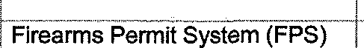

i

017/2?

SAPS/SITA SLA 2017/2018
” “” R” 5 919 04 00 ) ,

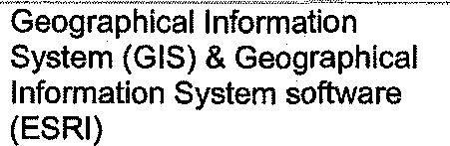
SAPSlSlTA SLA” R 1” 117 678, 80
2017/2018 R 668 628, 40

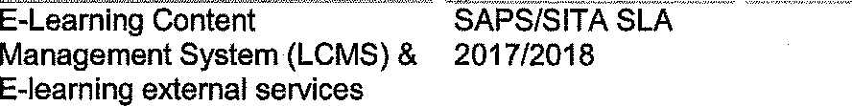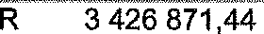
Management Support
System (RIMAS)
SAPS/SITA SLA
2017/2018
“ ” R“
1 764 022,27
IncdentRagister Information system (IRIS)
SAPS/SITA SLA 2017/2018
R
1 980 243,00 !
R
R
764 872,96
1 117 678,68
Ente“”rlse intent
n gEcM)
at
SAPS/SITA SL \ " " 2017/2018
R ” 6 532 381,96'•
R 1 204 042,04
z: g \ ne J e” D
SCM do U e t services POLFIN / CAPFIN
SAPS/SITA SLA 2017/2018
" R
14 8 030,11”
SAPS PERS & SALARY
SYSTEM (PERSAP / TAS)
SAPS/SITA SLA
2017/2018
R
7 879 756,32
Admini9tration
1
„ :m ›. ) I
1/ 2t
SLA
R "“ “12 851"426,72
INTERNET & INTRANET (Web
Slte)
SAPS/SITA SLA 2017/2018
R
2 345 027,85
Teephone Management System (TMS)
SAPS/SITA SLA 2017/2018
R R
5 850458,59
9108144,19

LIEUTENANT GENERAL IHSIONAL COMMISSIONER: TECHNOLOGY MANAGEMENT SERVICES
NP MASIYE

Reply to question 3305 recommended/nd

LIEUTENANT GENERAL DEPUTY NATIO OMMISSIONER: ASSET AND LEGAL MANAGEMENT FN VUMA

Reply to question 3305 recommended ed

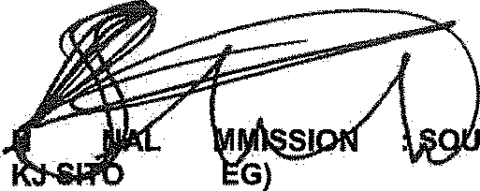
GENERAL
éTIO
CO LE (SO
ER
TH AFRICAN POLICE SERVICE

Date: zt 8 -11- 1
Reply ta question 3305 approved/

MINIS
BH CELE, MP
POLICE

