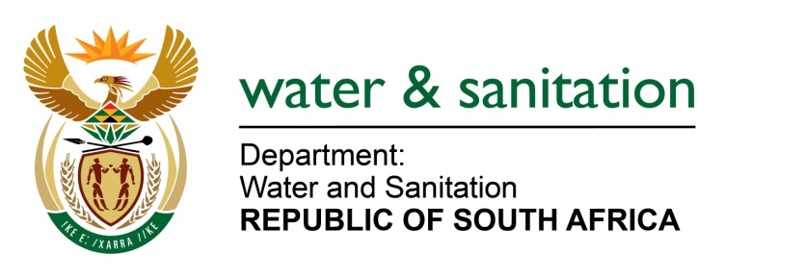

NATIONAL ASSEMBLY

FOR WRITTEN REPLY

QUESTION NO 3300

DATE OF PUBLICATION IN INTERNAL QUESTION PAPER: 23 SEPTEMBER 2022
(INTERNAL QUESTION PAPER NO. 36)

3300. Ms S A Buthelezi (IFP) to ask the Minister of Water and Sanitation:
Given that the Green Drop report indicates that half of the wastewater treatment works in the Republic fail to treat sewage properly and, in many cases, fail to treat it at all, (a) what steps have been taken by his department to capacitate Water Service Authorities in the Republic and (b)(i) which key focus areas has his department isolated from the specified report and (ii) how will they be addressed?
NW4097E
---00O00---

MINISTER OF WATER AND SANITATION

The Department of Water and Sanitation (DWS) recently published the 2022 Green Drop Report which gives a detailed overview of the state of Wastewater Management in the country. The report presents an extremely concerning situation across the country, and that wastewater management has deteriorated notably since 2014.

- The Department of Water and Sanitation has taken steps to capacitate Water Service Authorities in collaboration with the South Africa Local Government Association (SALGA) through:
- Capacitating the Water and Sanitation Portfolio based Councillors throughout their term.
- Ensuring adequate wastewater operations and maintenance capacity through the training of Process Controllers. The department will, in collaboration with the Energy and Water Sector Training Authority (EWSETA) facilitate training of Process Controllers in order to comply with the required Wastewater Quality Management regulations.
- Ensuring that all wastewater management environmental hazards are mapped and mitigated

Furthermore, the department together with SALGA embarked on the Water and Sanitation Councillor Induction from May to August 2022 across the country. Wastewater Quality Management and Drinking Water Management themes were part of the inductions.

- (i) Key focus areas identified in the report include the following:

- Technical competence
- Treatment capacity
- Wastewater monitoring and compliance
- Operation, Maintenance and Refurbishment of Assets

(ii) Key areas of concern identified during the Green Drop Assessments will be addressed in the following ways:
- The DWS is in the process of finalising the amendments to regulations relating to compulsory national standards for process controllers and water services works. The regulations seek to ensure that the water services works are classified according to their technology type to determine the level of skill required for operations by process controllers.
- Process controllers who are skilled in both qualifications and years of experience must be registered to operate a relevant water service works based on their class of certificate.
- The DWS is putting in place a Water Services Improvement Programme (WSIP) to strengthen its support and intervention at municipal level based on actual data or most available data. The aim of the programme is to ensure that support and intervention at municipal level is proactive, consistent, and systematic.
- Maintenance and refurbishment of Wastewater Treatment Works is the primary responsibility of the responsible Water Service Authorities (WSAs). However, the Department of Water and Sanitation (DWS) works together with the Department of Cooperative Governance and Traditional Affairs (COGTA) and the South African Local Government Association (SALGA) to ensure that municipalities receive the necessary support and grant funding to refurbish and maintain their assets.
- The DWS also funds certain refurbishment and upgrading projects that meet the criteria of the different funding programs such as Regional Bulk Infrastructure Grant (RBIG) and Water Services Infrastructure Grant (WSIG). Some of the specified WWTW have been gradually included in these programs depending on availability of funds availed to the Regions.
- COGTA also supports WSAs through the Municipal Infrastructure Grant (MIG) for water and sanitation services, amongst other. Some of the funding has been allocated for the refurbishment of some of WWTW.
---00O00---

