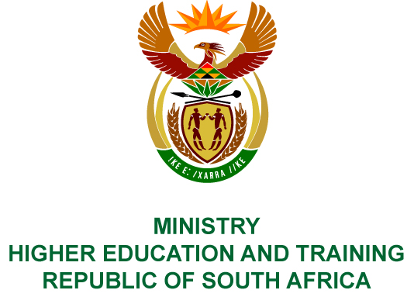
Private Bag X893, Pretoria, 0001, Tel (012) 312 5555, Fax (012) 323 5618
Private Bag X9192, Cape Town, 8000, Tel (021) 469 5150, Fax: (021) 465 7956
Memorandum from the Parliamentary Office
NATIONAL ASSEMBLY
FOR WRITTEN REPLY
QUESTION 33
DATE OF PUBLICATION OF INTERNAL QUESTION PAPER: 08/02/2018

(INTERNAL QUESTION PAPER NO 1 OF 2018)
Ms C King (DA) to ask the Minister of Higher Education and Training:
Whether her department has engaged with the Department of Science and Technology with regard to curriculum development for special skills such as reservoir engineering required for the exploration of shale gas; if not, why not; if so, what was the outcome of the engagement?
NW38E

REPLY:
The Department of Higher Education and Training (DHET) and Department of Science and Technology (DST) have an existing Memorandum of Cooperation (MoC) covering a number of areas of collaboration, including research and issues linked to academic planning for scarce skills.
It is the responsibility of the Council for Higher Education, through its Accreditation Directorate, to evaluate and accredit the programmes and the National Reviews Directorate, to engage with stakeholders, including government departments, on curriculum content.
The DHET provides assistance and guidance towards the formal approval of the programmes and ultimate inclusion of new academic programmes and qualifications on the universities’ programme and qualification mixes (PQMs).

COMPILER DETAILS
NAME AND SURNAME: MS PEARL WHITTLE
CONTACT: 012 312 5248
RECOMMENDATION
It is recommended that the Minister signs Parliamentary Question 33.

MR GF QONDE
DIRECTOR–GENERAL: HIGHER EDUCATION AND TRAINING
DATE:

PARLIAMENTARY QUESTION 33 IS APPROVED / NOT APPROVED / AMENDED.
COMMENT/S

PROF HB MKHIZE, MP
MINISTER OF HIGHER EDUCATION AND TRAINING
DATE:

