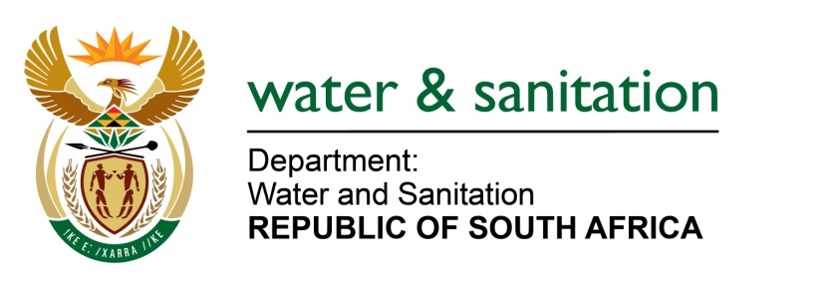

NATIONAL ASSEMBLY

FOR WRITTEN REPLY

QUESTION NO 3293

DATE OF PUBLICATION IN INTERNAL QUESTION PAPER: 28 AUGUST 2015
(INTERNAL QUESTION PAPER NO. 34)

3293. Ms M S Khawula (EFF) to ask the Minister of Water and Sanitation:
(1) (a)(i) What total amount did her department spend on her travel costs between Gauteng and Cape Town in the 2014-15 financial year and (ii) how many trips did she undertake between Gauteng and Cape Town in the specified financial year and (b) what total amount did her department spend on (i) hotel and (ii) residential or other accommodation for her in (aa) Cape Town and (bb) Pretoria in the 2014-15 financial year;
(2) (a)(i) what total amount did her department spend on the Deputy Minister’s travel costs between Gauteng and Cape Town in the 2014-15 financial year and (ii) how many trips did the Deputy Minister undertake between Gauteng and Cape Town in the specified financial year and (b) what total amount did her department spend on (i) hotel and (ii) residential or other accommodation for the Deputy Minister in (aa) Cape Town and (bb) Pretoria in the 2014-15 financial year? NW3897E
---00O00---
REPLY:
The trips undertaken were in line with the Parliamentary and Cabinet Programme as approved by Parliament and Cabinet respectively. The costs for trips undertaken by the Minister and the Deputy Minister were catered for in the 2014/15 financial year under programme 1: Administration.

---00O00---

