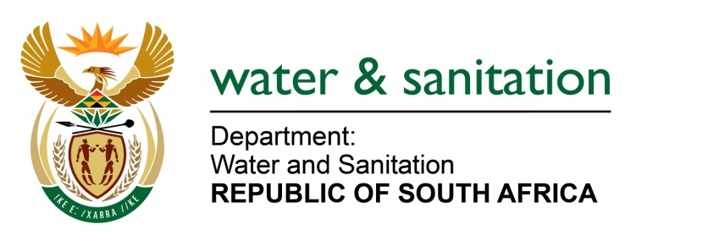

NATIONAL ASSEMBLY

FOR WRITTEN REPLY

QUESTION NO 3286

DATE OF PUBLICATION IN INTERNAL QUESTION PAPER: 23 SEPTEMBER 2022
(INTERNAL QUESTION PAPER NO. 36)

3286. Mr P Mey (FF Plus) to ask the Minister of Water and Sanitation:

(1) Whether his department has been informed that the residents of some suburbs in the Polokwane Local Municipality have been without water supply since the first week of August 2022 and that the specified municipality has apparently informed residents that water supply would probably only be restored by December 2022; if not, why not; if so, what measures is his department taking to intervene in the specified matter;

(2) whether he will make a statement on the matter?

NW4083E
---00O00---

MINISTER OF WATER AND SANITATION

- The Minister of Water and Sanitation is aware of the water supply shortages of water supply within the Polokwane Local Municipality particularly within the Polokwane City, the surrounding suburbs and Seshego township.

Polokwane LM receives daily water supply from three major sources comprising of the Ebenezer Water Treatment Works (WTW), Olifantspoort WTW and Dalmada WTW. The Ebenezer and Olifasproot plants are operated by the Lepelle Northern Water Board (LNWB) while Dalmada WTW is operated by Polokwane LM.

Polokwane City and Seshego has a total demand of 96.5 Ml/d and all possible sources can only supply the city with 88.4Ml/d and currently there is a deficit of 8.1 Ml/d. The city is authorized to abstract and or to treat 29.4 Ml/d while LNWB supplies 27 Ml/d from Olifastsproot WTW and 32 Ml/d from Ebenezer WTW.

Water supply to the Polokwane LM is also augmented through boreholes, some of which are non-operation and require repairs as indicated below:
- Sand River North: all fifteen (15) Boreholes are operational. Polokwane LM is pumping the boreholes in alternative to allow some of the boreholes to recharge and the total yield of the boreholes is 4.8 Ml/d
- Seshego Boreholes (Direct to Reticulation): out of six (6) boreholes, two (2) are not operational due to vandalism and the municipality is currently repairing the borehole.
- Marshall Boreholes: all five (5) boreholes are operational and currently producing 3.8 Ml/d

The WTWs supplying Polokwane are faced with challenges that impact on the ability of the municipality to supply water consistently to all residents as follows:
- The Ebenezer WTW
  - The plant is operated by LNWB and is highly affected by general interruption of electricity, currently affecting optimal water supply countrywide, which is supplied by the Greater Tzaneen LM
  - Greater Tzaneen LM is currently upgrading electricity infrastructure which supplies the Ebenezer WTW and discussions to explore whether Greater Tzaneen LM can isolate Ebenezer WTW from load shedding are underway
- Olifanspoort WTW
  - The plant is operated by LNWB is impacted negatively by the Olifantspoort ageing bulk water supply network contributes significantly to the interruption of water supply in the City of Polokwane.
  - The main cause of the water supply challenges in Polokwane City was due to deficiencies of the pumping systems of the Olifantspoort scheme. There were mechanical breakdowns within Pump Station No 2 and Pump Station No 3 which have since been repaired.
    - The LNWB has already commissioned Phase 1 for the upgrade and refurbishment of this bulk pipeline, a cost of R 32 million. Phase 2 which has been allocated R 38 and is meant to refurbish aging infrastructure will be completed by the end of October 2022
- The Dalmada WTW
  - This plant, which is operated by the City of Polokwane, has a pipeline that conveys raw water from Dap Naude sections of which is critically dilapidated.
  - A study that was done in 2019 has confirmed a need for refurbishment and upgrade of the pipeline to enable Polokwane LM to safely abstract of 14Ml/d from the dam, which would add 4.1Ml to the supply
  - The Implementation Readiness Studies for the refurbishment and upgrades is under consideration by the department.

- Seshego WTW

  - There is a 1.8 Ml/d deficiency in the system due to the new Seshego WTW Plant currently being non-operational while under construction.

To ensure proper resolution of the water supply plaguing the Polokwane LM, a task team led by both Deputy Ministers, the Executive Major of Polokwane and Chairperson of the Board of LNWB has been set up to resolve water supply challenges in the Polokwane LM. A technical task team led by the Municipal Manager of Polokwane LM, the Chief Executive Officer of LNWB and DWS officials has also been established. The task team will meet weekly to track progress on the restoration of water supply to Polokwane City including the Seshego township. The implementation of the action plan is at 85% and all major challenges are being resolved.

- A joint media briefing was held by both Polokwane LM, LNWB and the department on 5 September 2022. Furthermore, the Polokwane LM continues to update residents of Polokwane City including Seshego township on any development regarding the state of water supply.

---00O00---

