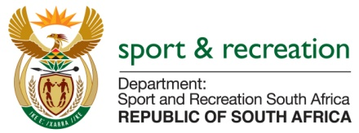

PARLIMENTARY QUESTION FOR THE MINISTER

QUESTION NO 3384

3384. ​Mr M S Malatsi (DA) to ask the Minister of Sport and Recreation:
(1)​(a) On what date was a fighting licence issued to the late Phindile Mwelase for her fight on 12 October 2014 with Liz Butler, (b) by which official at Boxing South Africa was the licence issued and (c) what was the position of the official who issued the licence at the time;
(2)​(a) who are the members of the team appointed to investigate the specified person’s death and (b) from which (i) company or (ii) department were the specified team members appointed;
(3)​what amount (a) has been budgeted for the investigation of the specified person’s death and (b) has been paid to the investigative team as at 25 August 2015;
(4)​has the investigative team submitted its (a) preliminary report and (b) final report; if not, (i) why not and (ii) when are the respective deadlines for submission of the specified reports; if so, when did the specified team submit the specified reports?​​NW4043E

REPLY

The Department is currently sourcing the information required from Boxing South Africa and will reply to the question when all information is available.

