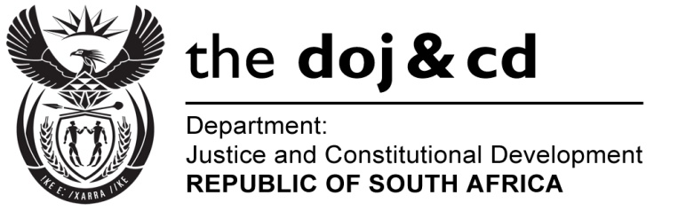

NATIONAL ASSEMBLY
QUESTION FOR WRITTEN REPLY
PARLIAMENTARY QUESTION NO.: 3285
DATE OF QUESTION: 28 AUGUST 2015
DATE OF REPLY: 11 SEPTEMBER 2015

Mr S P Mhlongo (EFF) to ask the Minister of Justice and Correctional Services:
- What (a) total amount did his department spend on air travel between Gauteng and Cape Town for employees attending Parliamentary business in the 2014-15 financial year and (b) is the total number of trips that were undertaken;
- What is the total amount that his department spent on (a) accommodation and (b) car rental in Cape Town for employees attending Parliament business in the specified financial year? NW2888E
REPLY:
(1)(a) An amount of R642 886-72 was spent on air travel in the financial year 2014/2015 for employees attending Parliamentary business during 2014-2015; and (b) 120 trips were undertaken;
(2)(a) An amount of R128 994-48 was spent on accommodation; and
(b) an amount of R55 007-56 was spent on car rentals, for employees attending Parliamentary business in Cape Town for the 2014/15 financial year.

