MINISTRY IN THE PRESIDENCY: WOMEN REPUBLIC OF SOUTH AFRICA

PRIVATE BAG x 1000, PRETORIA, 0001

Minister
Me o andu f he Pa I a e a O i e

National Assembly question for written reply: Question 3277

Ms D ree Legwale
CFO
Date:

Recommended /

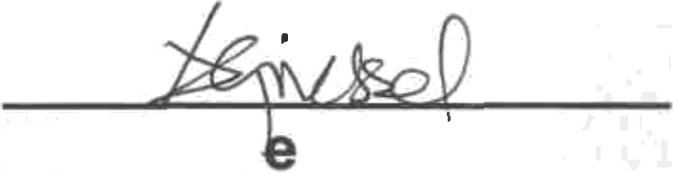
Acting Director General: Department of Women

Ms A Gri ssel

M GG M

M M GSM M M M M M M MG M

G R M M M R M G 1 8

NATIONAL ASSEMBLY QUESTION FOR WRITTEN REPLY QUESTION NUMBER: 3277
DATE OF PUBLICATION IN INTERNAL QUESTION PAPER: 02 NOVEMBER 2018
INTERNAL QUESTION PAPER NUMBER: 37

Ms M S Khawula (EFF) to ask the Minister of Women in The Presidency:
Whether (a) her Office and/or (b) entities reporting to her awarded any contracts and/or tenders to certain companies (names and details furnished) from 1 January 2009 up to the latest specified date for which information is available; if so, in each case, (i) what service was provided, (ii) what was the (aa) value and (bb) length of the tender and/or contract, (iii) who approved the tender and/or contract and (iv) was the tender and/or contract in line with all National Treasury and departmental procurement guidelines? NW3709E

Reply
- The department did not award any contracts and/or tenders to certain companies (names and details furnished) from 1 January 2009 up to the latest specified date for which information is available.

  - N/A
  - (aa) (bb) N/A
  - N/A
  - N/A

- The Commission Gender Equality is a Chapter 9 institution that reports to Parliament.
  - N/A
  - (aa) (bb) N/A
  - N/A
  - N/A

Ms BO Dlamini, MP
Minister in the Presidency Responsible for Women
Date: i I [\l I»=• lj

E F F Q U E S T 0 N F 0 R W R I T 7 E N R E P L Y 3 0 0 C T 0 8 E R 2 0 1 8
Hon M Khawula (EFF) to ask the Minister for Women in the Presidency
Whether your department or entities reporting to your department awarded contracts or tenders to DCD Group (2006/037611/07); Afrit (2009/018567/07); Elgin, Brown and Hamer (1994/003761), Hulisani Consortium (RF) (2015/033939), Elgin Dock (1999/002726/07), Diesel and Turbo Service Centre (1974/000105/07), Vox Telecommunications (2011/000797/07), Afrit Propco (1972/004953/07), Vox Holdings (2011/00g393/07), lnterpair Services (1995/002104/07), Simiglo (RF) (2013/017112/07), Cancerian Investments (1998/014612/07), Phuma Finance (1979/004736/07), between 2009 and 201B? If yes, what was the service provided? What was the value of the tender or contract? What was the length of the tender of contract? Who approved the tender or contract? Was the tender or contract in line with all National Treasury and departmental procurement guidelines?

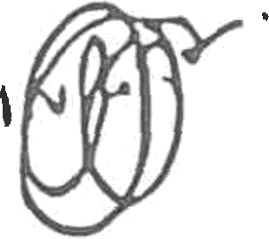

3 4 OCT 2Oj£

