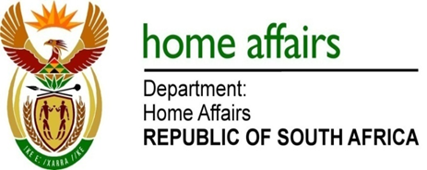

NATIONAL ASSEMBLY

QUESTION FOR WRITTEN REPLY

QUESTION NO. 3272

DATE OF PUBLICATION: Friday, 28 August 2015

INTERNAL QUESTION PAPER 34 OF 2015

3272. Ms H O Maxon (EFF) to ask the Minister of Home Affairs:

(1) What (a) total amount did his department spend on air travel between Gauteng and Cape Town for employees attending Parliament business in the 2014-15 financial year and (b) is the total number of trips that were undertaken;
(2) what is the total amount that his department spent on (a) accommodation and (b) car rental in Cape Town for employees attending Parliament business in the specified financial year? NW3874E

REPLY:

The Department’s records system on travel does not separate the different categories of business for trips and destinations. The department can however disclose/provide the total travel expenditure for 2014/2015, per category of air travel and car hire.

(1)(a) The department spent a total amount of R27 739 532.51 on various air travel in the 2014/15 financial year.

(1)(b) The total number of trips undertaken for the year 2014/2015 to/from various areas/destinations throughout the country are 9 986.

(2)(a) The total amount spent on accommodation in the 2014/15 financial year is R39 138 312.70.

(2)(b) The total amount spent on car rental is R6 586 431.57 for 2014/2015.

