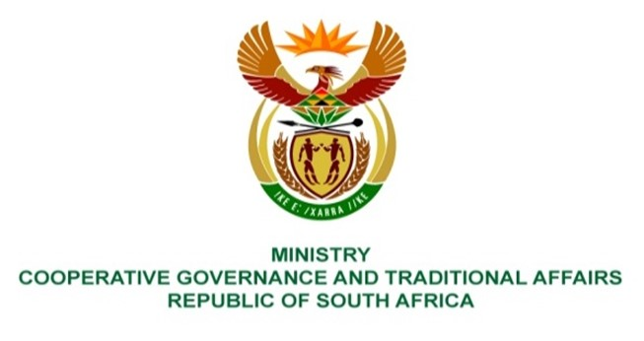

NATIONAL ASSEMBLY
QUESTION FOR WRITTEN REPLY

QUESTION NUMBER 327

327. Mrs L F Tito (EFF) to ask the Minister of Cooperative Governance and Traditional Affairs:
- Whether she has any powers to provide for the safety and security of community halls all over the Republic, which are increasingly becoming vandalised and dilapidated; if not, what is the position in this regard; if so,
- whether she intends using these powers; if not, why not; if so, what are the relevant details? NW342E

REPLY:
- No, the Minister does not have the powers referred to in the question. These are competencies of the South African Police Service and the municipal police service, where applicable, as contemplated in section 205 of the Constitution read with sections 13, 14, 64E and 64F of the South African Police Service Act, 1995 (Act No.68 of 1995).
- N/A.
End.

