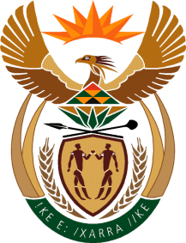

MINISTRY OF TOURISM
REPUBLIC OF SOUTH AFRICA

Private Bag X424, Pretoria, 0001, South Africa. Tel. (+27 12) 444 6780, Fax (+27 12) 444 7027
Private Bag X9154, Cape Town, 8000, South Africa. Tel. (+27 21) 469 5800, Fax: (+27 21) 465 3216

NATIONAL ASSEMBLY:

QUESTION FOR WRITTEN REPLY:
Question Number: 326
Date of Publication: 19 July 2019
NA IQP Number: 6
Date of reply: 2019

Mr G R Krumbock (DA) to ask the Minister of Tourism:

With reference to each tourism site that has become dilapidated in the past three years, (a) why have the specified sites become dilapidated, (b) what is being done to restore the sites to optimal condition and (c)(i) what are the timelines and/or time frames and deadlines to restore each site, (ii) how is this being monitored and (iii) by whom in each case? NW1293E

Reply:

(a)-(c)
The Department does not own or operate any tourism products, and can thus not account for the state of any tourism products. However, in the course of preparations for the Jobs Summit in 2018, the Department initiated a process to supplement a maintenance programme for major state owned products. This programme will train SMMEs with a focus on women, youth and cooperatives to undertake regular maintenance. In recognition of the tourism values of our National Parks, the three year programme is being piloted in National Parks, in collaboration with SANParks. Subsequent rollout of this programme will require a dedicated budget allocation, to prevent deterioration of products.

