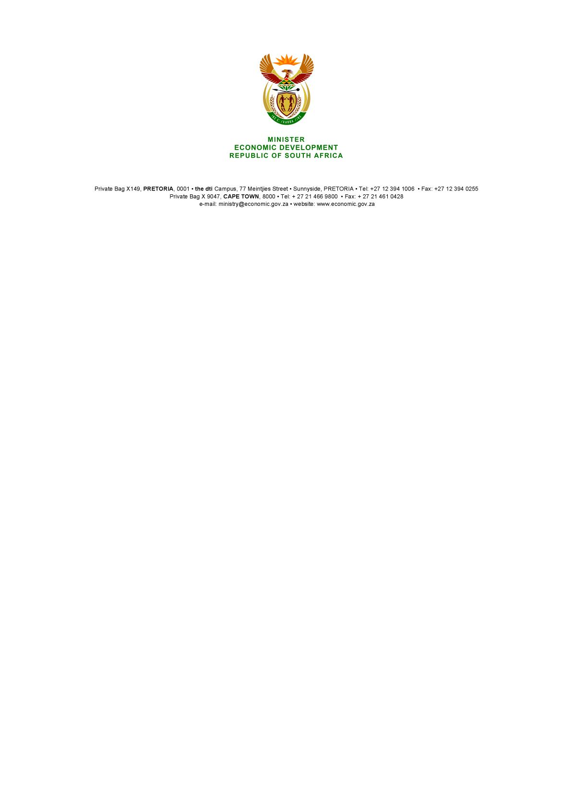

**NATIONAL ASSEMBLY**

**WRITTEN REPLY**

**PARLIAMENTARY QUESTION 326**

**DATE OF PUBLICATION: 22 February 2019**

**Mrs H O Mkhaliphi (EFF) to ask the Minister of Economic Development:** ***[Interdepartmentally transferred from Trade and Industry]***

(a) What amount of steel has the country (i) exported and (ii) imported in each of the past 10 years and (b) which trading country was steel (i) imported to and (ii) exported from in each case? NW347E

**Repl**y**:**

I have been furnished with the following data related to imports and exports of flat steel and long steel products:

Exports from South Africa between 2009 and 2018:

**Table 1: Steel Export statistics (Tons)**



Imports to South Africa between 2009 and 2018:

**Table 2: Steel Import statistics (Tons)**



ITAC advises that South Africa’s imports of steel originate mainly from the China, the UK, Japan and Germany. South Africa exports steel mainly to Zambia, Zimbabwe, the Democratic Republic of Congo and Mozambique.

Export destinations and import sources change from time to time however, and a more detailed study would need to conducted to see the changes in the composition of import/export trading partners.

A number of government initiatives are geared to increasing the level of steel beneficiation in South Africa. These include the expansion of localization in the processing of local scrap metal, support for steel-industry initiatives and the localization requirements for the use of steel in public infrastructure projects.

**-END-**