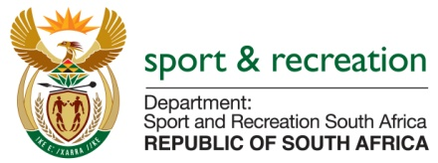

PARLIMENTARY QUESTION FOR THE MINISTER

QUESTION NO 3257

3257. ​Mr P G Moteka (EFF) to ask the Minister of Sport and Recreation:
(1)​What (a) total amount did his department spend on air travel between Gauteng and Cape Town for employees attending Parliament business in the 2014-15 financial year and (b) is the total number of trips that were undertaken;
(2)​what is the total amount that his department spent on (a) accommodation and (b) car rental in Cape Town for employees attending Parliament business in the specified financial year?​NW3859E

REPLY

The Department requires additional time to respond to this question as the details required needs sufficient time to collate. The Department of Sport and Recreation has a very small finance Directorate and will not be able to respond to this question within the period allocated to reply to questions.

