PRIVATE BAG x 1000, PRETORIA, 0001

Minister
Me ra d he Pa a e ta O e

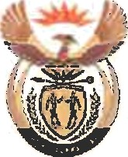

National Assembly question for written reply: Question 3256

Ms Desree Legwale

CFO
Date:

Recommended /

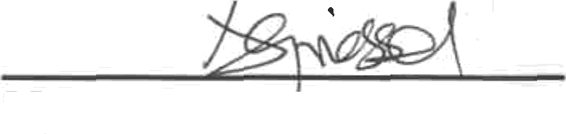

Ms A Griess‘el

Acting Director General: Department of Women

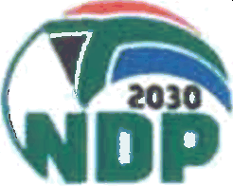
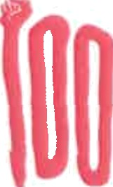
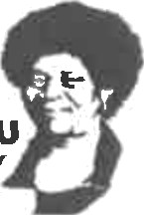

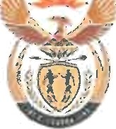
NATIONAL ASSEMBLY QUESTION FOR WRITTEN REPLY QUESTION NUMBER: 3256
DATE OF PUBLICATION IN INTERNAL QUESTION PAPER: 02 NOVEMBER 2018
INTERNAL QUESTION PAPER NUMBER: 37

Mr R A Lees (DA) to ask the Minister of Women in The Presidency:
What (a) amount did (i) her Office and (ii) each entity reporting to her borrow from any entity in the People’s Republic of China (aa) in each of the past three financial years and (bb) since 1 April 2018, (b) is the name of the lender of each loan, (c) conditions are attached to each loan and (d) are the repayment periods for each loan in each case? NW3686E

Reply
- (i) The Department did not borrow any amount from any entity in the People's Republic of China.
(aa) N/A (bb) N/A

(ii) The Commission Gender Equality is a Chapter 9
institution that reports to Parliament. (aa) N/A
(bb) N/A
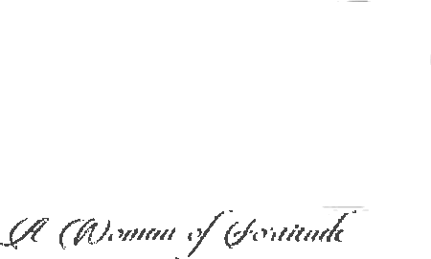
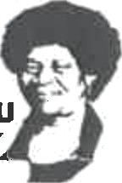

ALBEftTlf'4ASISULU

N/A
- N/A

N/A

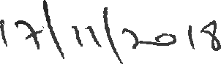
Ms BO Dlamini, MP Minister in the Date:

Responsible for Women

