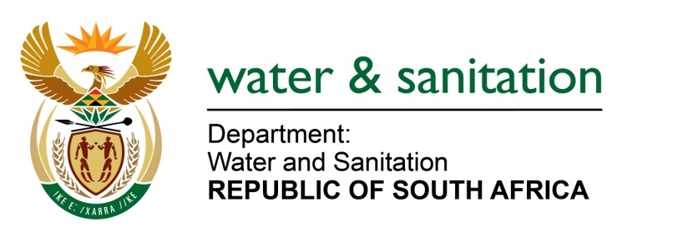

NATIONAL ASSEMBLY

FOR WRITTEN REPLY

QUESTION NO 3256

DATE OF PUBLICATION IN INTERNAL QUESTION PAPER: 28 AUGUST 2015
(INTERNAL QUESTION PAPER NO. 34)

3256. Ms M S Khawula (EFF) to ask the Minister of Water and Sanitation:
(1) What (a) total amount did her department spend on air travel between Gauteng and Cape Town for employees attending Parliament business in the 2014-15 financial year and (b) is the total number of trips that were undertaken;
(2) what is the total amount that her department spent on (a) accommodation and (b) car rental in Cape Town for employees attending Parliament business in the specified financial year? NW3858E
---00O00---
REPLY:
- The total amount spent on air travel and the total number of trips that were undertaken between Gauteng and Cape Town for employees attending Parliamentary business for the financial year 2014/2015 was as follows:

(1)(a) The total amount spent on air travel is R 8 436 100.63

(1)(b) The total number of air travel undertaken is 1852 between Gauteng and Cape Town for employees attending Parliamentary business for the financial year 2014/2015

- The total amount spent on accommodation and car rental costs in Cape Town for employees attending Parliamentary business for the financial year 2014/2015 was as follows:

(2)(a) The total amount that the department has spent on accommodation is R 4 624 218.12

(2)(b) The total amount that her department spent on car rental costs R 371 270.55
---00O00---

