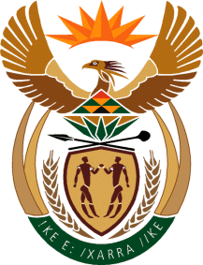

MINISTRY OF TOURISM
REPUBLIC OF SOUTH AFRICA

Private Bag X424, Pretoria, 0001, South Africa. Tel. (+27 12) 444 6780, Fax (+27 12) 444 7027
Private Bag X9154, Cape Town, 8000, South Africa. Tel. (+27 21) 469 5800, Fax: (+27 21) 465 3216

NATIONAL ASSEMBLY:

QUESTION FOR WRITTEN REPLY:
Question Number: 3252
Date of Publication: 2 November 2018
NA IQP Number: 37
Date of reply: 26 November 2018

Mr J J McGluwa (DA) to ask the Minister of Tourism:

What (a) amount did (i) his department and (ii) each entity reporting to him borrow from any entity in the People’s Republic of China (aa) in each of the past three financial years and (bb) since 1 April 2018, (b) is the name of the lender of each loan, (c) conditions are attached to each loan and (d) are the repayment periods for each loan in each case? NW3682E

Reply:
- Department:
The Department of Tourism has never borrowed money from any entity.

- SA Tourism:
South African Tourism, as indicated in its audited annual financial statements does not have any loans.

