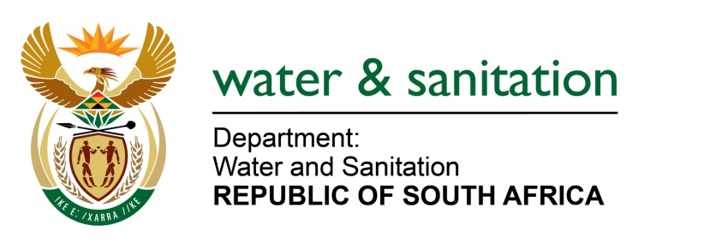

NATIONAL ASSEMBLY

FOR WRITTEN REPLY

QUESTION NO 3243

DATE OF PUBLICATION IN INTERNAL QUESTION PAPER: 16 SEPTEMBER 2022
(INTERNAL QUESTION PAPER NO. 33)

3243. Mrs M R Mohlala (EFF) to ask the Minister of Water and Sanitation:
In light of the fact that the Vaal Gamagara Regional Water Supply Scheme began in 2016 with a project completion date of May 2022, (a)what (i) was the initial estimated cost for the project and (ii) total amount has been spent to date and (b) how much work has been completed to date with the replacement of the existing steel pipeline with a new pipeline?
NW3976E
---00O00---

MINISTER OF WATER AND SANITATION

- (i) The initial estimated cost for the project was R 1,2 billion.
(ii) The total amount spent on the project was R 1,7 million.

- The project comprises on the replacement of 80km of pipeline, the installation of pressure
release valves and construction of chlorination building. These works were completed and
the pipeline is functional

---00O00---

