36/1/4/1(2018)
NA!TIONAL ASSEMBLY

FOR WRITTEN REPLY

QUESTION 3241
DATE OF PUBLICATION IN INTERNAL QUESTION PAPER: 2 NOVEMBER 2018 (INTERNAL QUESTION PAPER NO 37-2018)

3241. Mr S C Motau (DA) to ask the I\Minister of Police:

What (a) amount did (i) his department and (ii) each entity reporting to him borrow from any entity in the People’s Republic of China (aa) in each of the past three financial years and (bb) since 1 Apri! 2018, (b) is the name of the lender of each loan, (c) conditions are attached to each loan and (d) are the repayment periods for each loan in each case?
NW3671E
REPLY:

The Department of Police has not entered into any agreement that will allow for the borrowing of amounts from the People's Republic of China for any period of time.

MAJOR GENERAL ACTING DIVISIONAL COMMISSIONER
FINANCIAL MANAGEMENT AND ADMINISTRATION SJ NELSON

QUESTION 3241

Reply to question 3241 recommended/nd

LIEUTENANT-GENERAL oePuw NATIONAL I\/IMISSIONER: LEGAL AND ASSET MANAGEMENT FN VUMA

Reply to question 3241 recommended

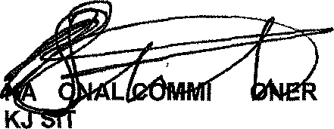
GENERAL
TI SSI : SOUTH AFRICAN POLICE SERVICE OLE (SOEG)

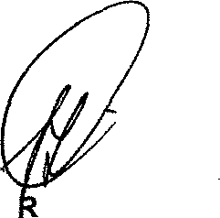
Reply to question 3241 approved/

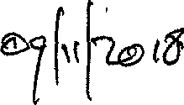
MINISTE FOR POLICE BH CELE, MP

Date:

