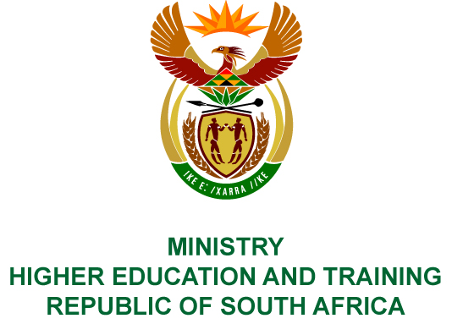
Private Bag X893, Pretoria, 0001, Tel (012) 312 5555, Fax (012) 323 5618
Private Bag X9192, Cape Town, 8000, Tel (021) 469 5150, Fax: (021) 465 7956
Memorandum from the Parliamentary Office
NATIONAL ASSEMBLY
FOR WRITTEN REPLY
QUESTION 3233
DATE OF PUBLICATION OF INTERNAL QUESTION PAPER: 02/11/2018
(INTERNAL QUESTION PAPER NO 37 OF 2018)
Mrs D Robinson (DA) to ask the Minister of Higher Education and Training:
What (a) amount did (i) her department and (ii) each entity reporting to her borrow from any entity in the People’s Republic of China (aa) in each of the past three financial years and (bb) since 1 April 2018, (b) is the name of the lender of each loan, (c) conditions are attached to each loan and (d) are the repayment periods for each loan in each case?
NW3663E
REPLY:
- The Department and its entities have not borrowed money from any entity in the People’s Republic of China.
- Not applicable.
- Not applicable.
- Not applicable.

