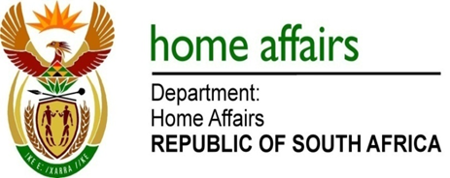

NATIONAL ASSEMBLY

QUESTION FOR WRITTEN REPLY

QUESTION NO. 3230

DATE OF PUBLICATION: Friday, 28 August 2015

INTERNAL QUESTION PAPER 34 OF 2015

3230. Mr A M Figlan (DA) to ask the Minister of Home Affairs:

When will all South Africans, not only pensioners and individuals during their birth months, be able to make applications for the new Smart ID cards? NW3831E
REPLY:

I will make a determination once all offices have sufficient capacity to handle the volumes of applicants for Smart ID cards. Currently office managers were given permission to apply their own discretion and accept other categories of citizens based on the volumes in their offices.

