NATIONAL ASSEMBLY
36/1/4/1(201900042)

FOR WRITTEN REPLY QUESTION 323

DATE OF PUBLICATION IN INTERNAL QUESTION PAPER: 22 FEBRUARY20_19 (INTERNAL QUESTION PAPER NO 3-2019)

323. Mr N S Matiase (EFF) to ask the Minister of Police:

What number of cases of corruption were opened with the SA Police Service in 2018?
NW344E
REPLY:

The number of corruption cases, registered with the South African Police Service (SAPS), Division: Detective Service, in 2018, is 514.

Reply to question 323 recommended/

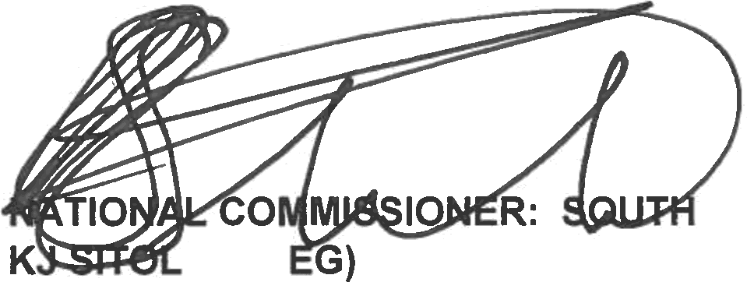
GENERAL AFRICAN POLICE SERVICE
E (SO

Date: j gjg -0t- 0 6

Reply to question 323 approved/not approved

MINISTER OF POLICE BH CELE, MP

Date:

