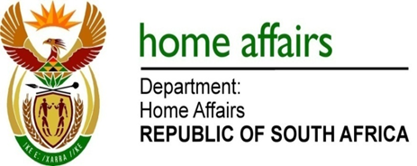

NATIONAL ASSEMBLY

QUESTION FOR WRITTEN REPLY

QUESTION NO. 3228

DATE OF PUBLICATION: Friday, 28 August 2015

INTERNAL QUESTION PAPER 34 OF 2015

3228. Mr A M Figlan (DA) to ask the Minister of Home Affairs:

What measures has his department put in place to address significant underspending on (a) building maintenance and (b) computer hardware and software resources in its various offices in the country?
NW3829E
REPLY:

(a-b) The department is not significantly underspending on its budget allocations and continues to face serious budget pressures that constrain it from properly maintaining and improving its current office accommodation and expanding its footprint. These budget pressures also limit the department from refreshing its hardware and computer infrastructure on a planned basis. In this regard, it should be noted that the department utilised its full appropriation of R7,223 billion (100%) in the 2014/2015 financial year. This is an improvement on the expenditure outcome in the 2013/2014 financial year when 99,99% of the full appropriation of R6,994 billion was spent. National Treasury is engaged constantly to address the budget pressures the department faces. Treasury has in the past provide budget relief in the form of self-financing.

