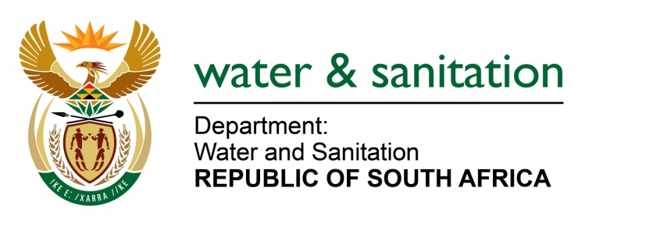

NATIONAL ASSEMBLY

FOR WRITTEN REPLY

QUESTION NO 3223

DATE OF PUBLICATION IN INTERNAL QUESTION PAPER: 28 AUGUST 2015
(INTERNAL QUESTION PAPER NO. 34)

3223. Mrs Z B N Balindlela (DA) to ask the Minister of Water and Sanitation:
Did National Treasury approve her department’s requested rollover of (a) R1 600 899 000 for Programme 1, 2, 4 and 5 and (b) R1 557 184 000 in respect of each economic classification from the 2014-15 to the 2015-16 financial year; if not, (i) why not and (ii) what is the implication of this decision; if so, when? NW3824E
---00O00---
REPLY:

National Treasury has not yet approved my Department’s request for rollovers of R1 600 899 000 for Programme 1, 2, 4 and 5; and R1 557 184 000 in respect of each economic classification from the 2014-15 to the 2015-16 financial year.

National Treasury will only communicate the outcome of the rollover process on or before 11 September 2015 through the approved allocation letters as per the Guidelines of 2015 Adjustment Estimates of National Expenditure.

The non-approval of the requested rollover funds will necessitate the need for my Department to reprioritise the existing allocations for 2015/16 financial year within the programmes. This will result in the rescheduling of some of the infrastructure projects earmarked for the current year.

---00O00---

