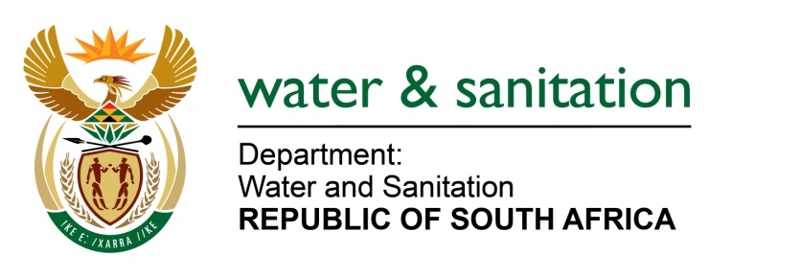
NATIONAL ASSEMBLY

FOR WRITTEN REPLY

QUESTION NO 3222

DATE OF PUBLICATION IN INTERNAL QUESTION PAPER: 28 AUGUST 2015
(INTERNAL QUESTION PAPER NO. 34)

3222. Mr L J Basson (DA) to ask the Minister of Water and Sanitation:
(1) Whether her department is monitoring the quality of the water in the Great Fish River; if not, why not; if so, (a) how is this being done and (b) how often;
(2) whether the Great Fish River is part of the River Health Scheme; if not, why not;
(3) whether her department has put any measures in place to prevent the pollution of bulk water schemes downstream of the Cradock Wastewater Treatment plant; if not, why not; if so, what are the relevant details;
(4) whether she can provide the latest Green Drop status of the Cradock Wastewater Treatment plant; if not, why not; if so, what are the relevant details;
(5) whether any action was taken by the Chris Hani District Municipality in response to her department’s notice to comply within 14 days which expired on 11 February 2015; if not, what action did her department take in response to this; if so, what are the relevant details? NW3823E
---00O00---
REPLY:
(1) Yes ,my Department is monitoring the quality of water in the Great Fish River.
(1)(a) Through sampling of the water quality.
(1)(b) Monitoring is conducted on a quarterly basis.
(2) Yes, it is part of River Health Programme.
(3) My Department has issued a number of regulatory actions to the polluters. Action such as Non compliance notice and Pre-Directive are issued. Whilst Chris Hani District
Municipality (CHDM) did attend to some of the issues and did provide an action plan, this plan was not detailed enough to address the non compliances.
(4) The last compliance inspection was conducted on 16 September 2014 and was not in good condition. A non-compliance letter and a pre-directive were issued. Further meetings were held to discuss the status of the system.
(5) At the July 2015 site visit it was observed that repairs were being conducted to a horizontal aerator and to one of the two circular clarifiers. Two of the vertical shaft aerators were in operation and eleven of the horizontal shaft aerators were defunct and in various states of disrepair. The two inclined screw pumps were out of order and appeared to be partly dismantled or under repair. NW3823E
---00O00---

