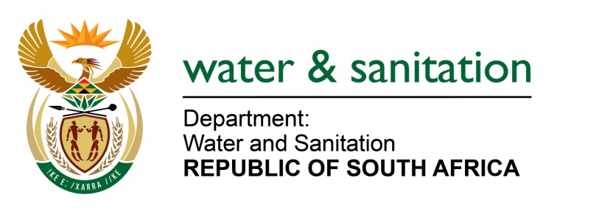
NATIONAL ASSEMBLY

FOR WRITTEN REPLY

QUESTION NO 3221

DATE OF PUBLICATION IN INTERNAL QUESTION PAPER: 28 AUGUST 2015
(INTERNAL QUESTION PAPER NO. 34)

3221. Mr L J Basson (DA) to ask the Minister of Water and Sanitation:

(1) Whether there has been an improvement of service and fewer water interruptions since the Chris Hani District Municipality became the water service provider in the municipality from 1 July 2014; if not, why not; if so, what are the relevant details;

(2) whether her department will assist the specified municipality with ageing and inadequate infrastructure; if not, why not; if so, what are the relevant details;

(3) whether her department will assist with the non-functioning new standby generator at the main pumping station; if not, why not; if so, what are the relevant details;

(4) will her department intervene to improve the water service in the specified municipality; if not, why not; if so, what are the relevant details;

(5) what is the latest Blue Drop score for the purification plant in the specified municipality? NW3822E

---00O00---
REPLY:
- Yes, the Blue Drop System does show that during the period when InxubaYethemba Local Municipality (LM) was in control, the number of samples which were taken were higher (430 per year) than when Chris Hani DM was in control (122 samples per year). The quality compliance improved though in terms of turbidity (from 47,1% to 85,1%) and ecoli(from95% to 100%) since Chris Hani DM took over. The challenge currently is on the billing system as users have not been getting their accounts on services of the InxubaYethemba LM since Chris Hani DM took over the Water Services Provider (WSP) function. The turnaround time to repair leaks is still a challenge, but there is constant intervention from the Department through the Rapid Response Unit(RRU). Unfortunately, it cannot be said that the water service has improved since the Chris Hani DM took over.

- There is currently no funding dedicated for the aging and inadequate infrastructure but the technical support is provided.

- The Chris Hani DM purchased standby generators for both main water and main sewer pump stations which are currently the subject of the dispute with the service provider. According to Chris Hani DM, the dispute is on the verge of being resolved with the service provider.

- Yes, there are ongoing interventions on a call down basis through the RRU and Operation and Maintenance O&M technical support.

- The latest Blue Drop score is 71%.

--00O00---

