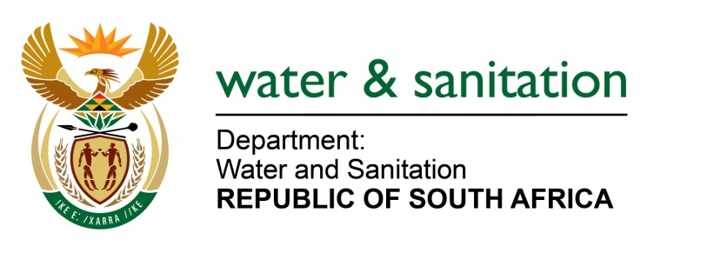
NATIONAL ASSEMBLY

FOR WRITTEN REPLY

QUESTION NO 3220

DATE OF PUBLICATION IN INTERNAL QUESTION PAPER: 28 AUGUST 2015
(INTERNAL QUESTION PAPER NO. 34)

3220. Mr L J Basson (DA) to ask the Minister of Water and Sanitation:
(1) Why is the wastewater treatment plant in Cradock which is under the control of the Chris Hani District Municipality and polluting the Great Fish River in the Eastern Cape
non-functional;
(2) whether her department has taken any steps to stop the pollution; if not, why not; if so, what are the relevant details;
(3) whether sampling of water has been done (a) at the plant and (b) downstream from the plant to ascertain e-coli levels for each month during the period 1 July 2012 to 30 July 2015; if not, why not; if so, what are the results for each month during the specified period;
(4) whether there are any plans to upgrade the plant; if not, why not; if so, (a) when and (b) what is the estimated cost;
(5) what is the (a) current capacity of the plant in megalitres per day and (b) inflow currently? NW3821E
---00O00---
REPLY:

- The non-functionality of Cradock Wastewater Treatment Works (WWTW) is attributed to the Water Service Authority functions transitioning from InxubaYeThemba Local Municipality to Chris Hani District Municipality, as it has been the case since 2014. This has been an inheritance of financial burdens which has adversely affected the whole operation and maintenance at the plant and at the sewage pump stations.Payments to maintenance service providers had been delayed as such some arms of the plant (motors, aerators, pumps, etc) that have since broken down and have not been repaired or replaced.

These are now attended to and the Cradock WWTWwill be fully repaired and will function at an optimum level in due course.

(2) My Department has taken steps to notify and request the Municipality to take corrective steps in rectifying the pollution of the Great Fish River water resource caused by the
non-functionality of Cradock WWTW and its associated sewer network infrastructure.

The following are amongst a number of steps taken by my Department:

- Firstly, my Department issued a non-complianceletteron 2 April 2013 informing the Municipality about the poor quality effluent discharged and the incorrect disposal of the sewage sludge from the Cradock WWTWs, copy of letter attached as Annexure A.

- Secondly, officials from my Department’s Provincial Office: Eastern Capeconducted aninvestigation on 1 August 2014 into the allegedpollution and it was revealed that pollution still persists. Therefore,myDepartment issuedanother non-compliance letter to

-2-

the Municipalityon 11 August 2014 regarding pollution incidents entailing sewage spillages from manholes in Cradock, copy of letter attached as Annexure B/

- Thirdly, myDepartment also served the Municipality with non-compliance letter on 25 September 2014 following another site inspection that was conducted on
16 September 2014 informing the Municipality about poor quality effluent discharged by the Cradock WWTWs and requesting the Municipality to submit an action plan taken by the municipality in rectifying the situation within 14 days.

- Thefourth interaction was a meeting that was held between Chris Hani District Municipality, Great Fish Water User Association,InxubaYeThemba Local Municipality and myDepartment at the Municipal Offices in Cradock on 10 February 2015 ,refer to attached Annexure C for minutes with actions and attendance register).

The aim was to further engage and persuade the Chris Hani DM as Water Services Authority to take action and correct the poor quality effluent being discharged by the Cradock WWTW into the Great Fish River. In this meeting the Municipality indicated the challenges (as mentioned in (1) above) promising to attend to the challenges with a detailed written response by 16 February 2015 as requested by myDepartment as was done even in previous communiqués, refer to attached Annexure D for the minutes of the .

It should be noted that there has not been any written response as yet from the Municipality after these engagements.

During the last inspection which was conducted on 12 August 2015, the presence of the Contractor on site was noted on site repairing some of the various arms of theWWTW.

(3) Table 1below is the summary of the effluent quality discharged by the (a) Cradock Wastewater Treatment Works and the (b) Great Fish River, downstream of the discharge point from the Cradock Works:

Table 1
Sampling Dates | - Cradock WWTW | - Downstream of Cradock WWTW
July 2012 | 0 cfu/100ml | 58 cfu/100ml
August 2012 | 66 cfu/100ml | 128 cfu/100ml
September 2012 | 7 500 cfu/100ml | 86 cfu/100ml
October 2012 | 0 cfu/100ml | 400 cfu/100ml
January 2013 | 2 cfu/100ml | 7 000 cfu/100ml
March 2013 | 10 cfu/100ml | 3 400 cfu/100ml
April 2013 | 0 cfu/100ml | 4 400 cfu/100ml
May 2013 | 7 200 cfu/100ml | 420 000 cfu/100ml
June 2013 | 520 cfu/100ml | 164 cfu/100ml
May 2014 | 0 cfu/100ml | 24 000 cfu/100ml
June 2014 | 0 cfu/100ml | 24 000 cfu/100ml
September 2014 | 35 000 cfu/100ml | 1 900 cfu/100ml
December 2014 | 37 000 cfu/100ml | 40 000 cfu/100ml
February 2015 | 390 000 cfu/100ml | 710 cfu/100ml
June 2015 | 4 600 000 cfu/100ml | 42 000 cfu/100ml
August 2015 | 108 cfu/100ml | 294 cfu/100ml

-3-

It should be noted my Department also done water sampling in August month for both Cradock WWTWs and the Great Fish River, downstream of the discharge point from the Cradock Works and the results are 108 cfu/100ml and 294 cfu/100ml respectively.

(4) No, the Department has not taken any plans to upgrade the WWTWs. The dysfunctional elements of the WWTWsare largely due to the lack of operation and maintenance at the WWTW and reticulation infrastructure, which if properly managed will render the works effective in its treatment of the sewage received.

The Upgrading of the WWTW would not seem to benecessary at this point unless further major developments are anticipated in the area. However, the Water Service Authority is currently attending to these repairs.

(4)(a) Falls Away.

(4)(b) Falls Away.

(5)(a) The current capacity of the plant is 8.3 mega litres per day.
(5)(b) The currently inflow is 5.6 mega litres per day average.

---00O00---

