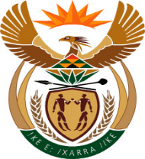

MINISTER IN THE PRESIDENCY: PLANNING, MONITORING AND EVALUATION
REPUBLIC OF SOUTH AFRICA
QUESTIONS FOR WRITTEN REPLY
FRIDAY, 2 November 2018

3213. Mr Y Cassim (DA) (p 1117)—Minister in The Presidency.

Has the National Youth Development Agency (NYDA) subsidised in any way movie tickets for the viewing of the film Black Panther; if so, does this fall within the approved programmes of the NYDA in terms of their annual performance plan? NW3642E

REPLY
- The NYDA has not subsidised movie tickets for the viewing of the film Black Panther.

 |  | Approved | Not  Approved | Approved  as amended
 |  | Comment:
Dr NC Dlamini-Zuma
Minister in the Presidency: Planning Monitoring and Evaluation
Date:

