

**MINISTER OF TOURISM**

**REPUBLIC OF SOUTH AFRICA**

Private Bag X424, Pretoria, 0001, South Africa. Tel. (+27 12) 444 6780, Fax (+27 12) 444 7027

Private Bag X9154, Cape Town, 8000, South Africa. Tel. (+27 21) 469 5800, Fax: (+27 21) 465 3216

**NATIONAL ASSEMBLY:**

**QUESTION FOR WRITTEN REPLY:**

**Question Number: 321**

**Date of Publication: 19 July 2019**

**NA IQP Number: 6**

**Date of reply: 26 August 2019**

**Mr M S F de Freitas (DA) to ask the Minister of Tourism:**

(1) (a) What are the monthly statistics with reference to domestic tourism (i) in the past three years and (ii) since 1 January 2019, (b) where did the tourists travel to in each month, (c) what targets were set in this regard and (d) how did the set targets measure up to actual number of arrivals at domestic travel destinations in each month;

(2) (a) what is being done to ensure that tourism targets set are met and (b) how are these targets measured;

(3) (a) how is South African tourism marketed (i) in countries abroad and (ii) locally and (b) what budgets have been allocated in this regard for the next three years? NW1288E

**Reply:**

(1)(a) (i) and (ii)

**Total domestic trips**



Note: Data reported in millions

Source: South African Tourism domestic surveys

**Domestic holiday trips**



Note: Data reported in millions

Source: South African Tourism domestic surveys

1. (b) Where did the tourist travel each month?

Provincial distribution cannot reliably be reported on at a monthly level. Data is provided at an annual level.

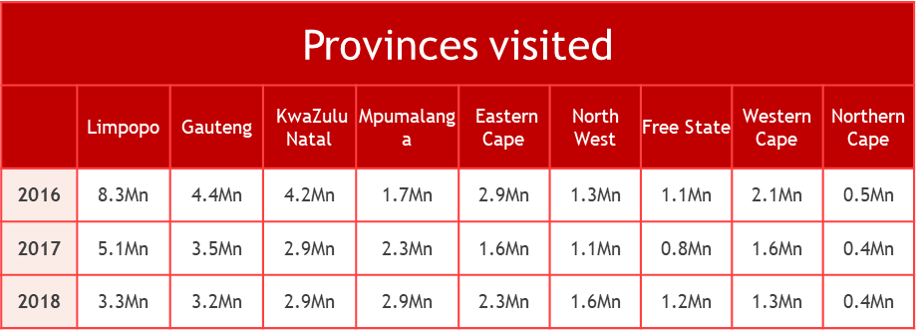

(c) What targets were set in this regard?

Targets on the number of total domestic trips per destination are set on an annual basis not on a Monthly basis

(d) How did the targets set, measure up to actual number of arrivals at domestic travel destinations each month?

Not Applicable. Refer to response (c)

(2) (a) what is being done to ensure the targets that were set are met?

Refer to response 1(c)

(b) How are these targets measured?

Refer to response 1(c)

(3)(a) How is SA tourism marketed

Marketing the South Africa a tourist destination is the responsibility of the Department of Tourism and this responsibility is shared between the department and its implementation entity South African Tourism. The latter devices programmes aimed at marketing the country with the support of the department. In addition, SAT has established stations in almost all the major regions of the world to implement marketing programmes tailored to suit each region and in some instances to suit countries within a region. South African Tourism’s marketing approach is two-pronged focussing on building a unified brand and marketing communications plan and leveraging synergistic partnerships

1. Countries abroad

South African Tourism has a defined selection of prioritised markets that have been shortlisted for dedicated in-market marketing investments, based on their tourism potential and SA Tourism’s ability to win in these markets.

South African Tourism’s strategy is to market a unified brand in order to improve brand awareness and positivity by building brand appeal among first-time and repeat tourists, through the provision of information that shows South Africa as a value-for-money, safe and secure destination that offers unique and varied experiences.

This is achieved in the following ways:

* Marketing South Africa in its different markets and segments using different channels that provide user-friendly and fit for purpose content to consumers as well as trade and partners that sell South Africa as a tourism destination;
* Implementing an enhanced 360-degree global communications plan that conveys appealing messages to consumers, trade and media; and
* Supporting Brand SA’s reputation management strategy.

Marketing campaigns in countries are localised based on the global brand campaign and target the following segments:

* Wanderluster Segment who are older wealthier and experienced international travellers between the ages of 40 and 60
* Next Stop South Africa (NSSAs) Segment who are younger singles or couples between the ages of 25 and 50 with considerable travel experience.
* Niche Market Segments such as Millenials, LGBTQ+, African Americans and others.

Key Business drivers for international tourism marketing are:

* Hostings
* In-Country Roadshows
* Domestic and International Trade Platforms
* Trade Training and
* Strategic Partnerships

1. Locally

The Domestic Tourism Marketing Strategy focusses on inspiring the targeted segments of travellers to take more trips by showcasing a variety of affordable, desired experiences in a clear and accessible manner using the Domestic Sho’t Left Campaign. The Campaign is executed through a mix of various channels such as social media, radio and television, out of home marketing as well as a number of various consumer and trade activations and partnerships.

For domestic tourism, target travel groups are identified based on the degree of holiday-taking culture, which can be differentially targeted according to the behaviour that underpins the segment. The focus segments targeted through domestic tourism marketing initiatives are:

* The Build Segment has the appropriate socio-economic background and is not travelling and thus there is a need to build a culture of travel within this grouping.
* The Convert Segment are people who travel for a number of reasons, but not necessarily and need to be converted to travel for a holiday.
* The Defend Segment is mature in terms of holiday travel and there is therefore a need to defend this market and up-sell where possible.

SA Tourism also partners with and educates the distribution channel (traditional and non-traditional) to package and promote relevant deals supporting affordable, consumer-desired holiday and business events experiences, to encourage our prioritized segments to book and travel.

(b) What budgets have been allocated in this regard for the next three years

|  |  |  |  |  |
| --- | --- | --- | --- | --- |
| **Name of the Programme** | | **2020/21** | **2021/22** | **2022/23** |
|  |  |  |
|  | | **Budget** | **Budget** | **Budget** |
| **(R’000)** | **(R’000)** | **(R’000)** |
| 1 | Corporate Support | 135 033 | 140 926 | 146 483 |
| 2 | Business Enablement | 90 743 | 94 704 | 98 438 |
| 3 | Leisure Tourism Marketing | 1 083 397 | 1 130 676 | 1 175 257 |
| 4 | Business Events | 135 029 | 140 922 | 146 479 |
| 5 | Visitor Experience | 69 494 | 72 526 | 75 386 |
| **Total** | | **1 513 696** | **1 579 755** | **1 642 043** |