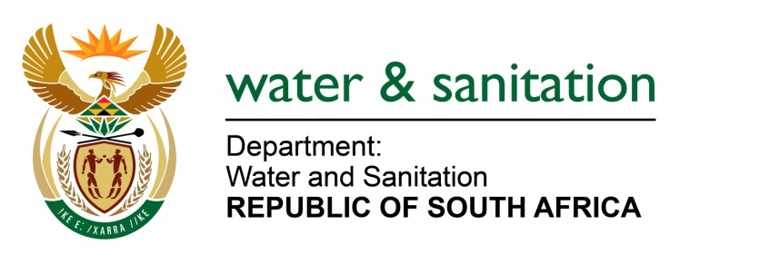

NATIONAL ASSEMBLY

FOR WRITTEN REPLY

QUESTION NO 320

DATE OF PUBLICATION IN INTERNAL QUESTION PAPER:
(INTERNAL QUESTION PAPER NO. 2) 17 FEBRUARY 2023

320. Ms P Madokwe (EFF) to ask the Minister of Water and Sanitation:
What role has his department played in holding the mine accountable for (a) the slimes dam disaster in Jagersfontein in the Free State and (b) enforcing safety regulations, given that it has been nearly five months since the disaster and that victims have been left stranded with family members in nearby towns and those whose homes are being rebuilt are receiving subpar housing that is not close to the houses that were destroyed? NW335E
---00O00---

MINISTER OF WATER AND SANITATION

- The Department of Water and Sanitation issued a directive to Jagersfontein Developments (Pty) Ltd on 12 September 2022, in terms section 20 (4) of the National Water Act (NWA), 1998 (Act No. 36 of 1998), relating to control of emergency incidents. Amongst other issues, the directive requested rehabilitation of all the affected areas from the Wolwas dam in the Proses Spruit and from the dam downstream towards the confluence of the Proses Spruit and Kromellenboog, downstream to the confluence of the Kromellenboog and Riet Rivers and into the Kalkfontein Dam.

Jagersfontein Developments (JD) has since submitted the incident and rehabilitation plans to DWS which were evaluated and sent back for corrections and improvements in October 2022. The rehabilitation action plan was resubmitted to DWS in December 2022 and DWS has provisionally accepted the plan with the view that the updated plan will be submitted after the appointment of additional specialists as stated in the response submitted in December 2022 by JD. The DWS is continuing to monitor progress regarding the implementation of the rehabilitation plan which has already commenced.

Further to that, the department has opened a criminal case with the Jagersfontein South African Police Services (SAPS) against the owners of Jagersfontein Mine, Jagersfontein Development, for possible contraventions of Section 151(1) (f) & (i) read with Section 1 and 151(2) of the NWA. The DWS is also in the process of appointing a panel of tailings experts to carry out an independent forensic investigation on the causes of failure of the tailings storage facility (TSF). The final report of the forensic investigation will be made available to Parliament.

- The Department issued a Dam Safety directive in terms of section 118 of the NWA, compelling Jagersfontein Development (JD) to decant Compartment 2 which still had fine tailings to prevent a secondary failure of the TSF. In addition, JD was directed to appoint an Approved Professional Person (APP) to oversee and advise the mine on the safety and operations, including but not limited to decanting Compartment 2 of the TSF at an appropriate rate to safeguard the risk of failure of the said compartment. The APP appointment was approved by the department’s Dam Safety Office (DSO). The DWS is not able to respond on the query regarding the rebuilding of the houses. We are requesting the Honourable Member to redirect this question to the Department of Human Settlements.

---00O00---

