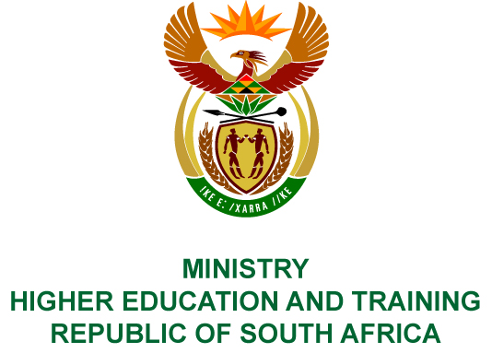
Private Bag X893, Pretoria, 0001, Tel (012) 312 5555, Fax (012) 323 5618
Private Bag X9192, Cape Town, 8000, Tel (021) 469 5150, Fax: (021) 465 7956
Memorandum from the Parliamentary Office
NATIONAL ASSEMBLY
FOR WRITTEN REPLY
QUESTION 320
DATE OF PUBLICATION OF INTERNAL QUESTION PAPER: 16/02/2018

(INTERNAL QUESTION PAPER NO 2 OF 2018)
Mr D Bergman (DA) to ask the Minister of Higher Education and Training:
What amount did (a) her department and (b) each entity reporting to her spend on the promotion or celebration of the Year of O R Tambo on the (i) Africa News Network 7 channel, (ii) SA Broadcasting Corporation (aa) television channels and (bb) radio stations, (iii) national commercial radio stations and (iv) community (aa) television and (bb) radio stations since 1 January 2017?

NW342E
REPLY
(a) and (b) None.

