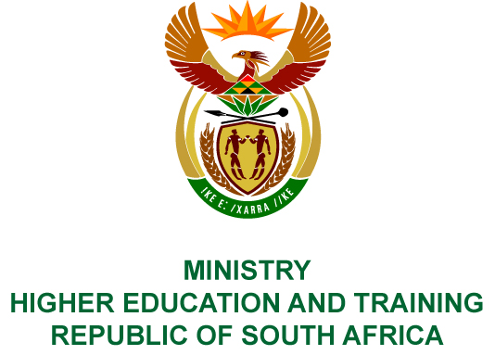
Private Bag X893, Pretoria, 0001, Tel (012) 312 5555, Fax (012) 323 5618
Private Bag X9192, Cape Town, 8000, Tel (021) 469 5150, Fax: (021) 465 7956
Memorandum from the Parliamentary Office
NATIONAL ASSEMBLY
FOR WRITTEN REPLY
QUESTION 32
DATE OF PUBLICATION OF INTERNAL QUESTION PAPER: 08/02/2018

(INTERNAL QUESTION PAPER NO 1 OF 2018)
Mr A P van der Westhuizen (DA) to ask the Minister of Higher Education and Training:
- What was the total cost of the Commission of Inquiry into Higher Education and Training Fees Commission and (b) from which department’s budget were the funds sourced?
NW37E

REPLY:
The President of the Republic of South Africa established the Commission of Inquiry into Higher Education and Training, and matters pertaining thereto were dealt with by the Presidency.

