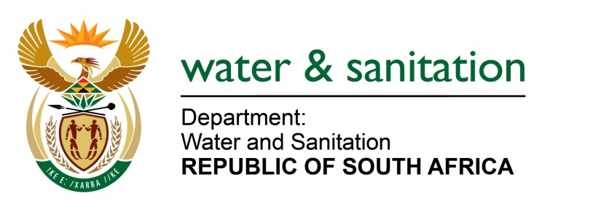

NATIONAL ASSEMBLY

FOR WRITTEN REPLY

QUESTION NO 3198

DATE OF PUBLICATION IN INTERNAL QUESTION PAPER: 16 SEPTEMBER 2022
(INTERNAL QUESTION PAPER NO. 33)

3198. Mr M Chetty (DA) to ask the Minister of Water and Sanitation:
(1) On what date did he attend the last meeting of any structure outside the Government in order to receive recommendations on the deployment of personnel in his department and/or entities reporting to him.
(2) whether any appointments to his department and/or entities reporting to him were discussed during his attendance at any private forum and/or external structures to the Government; if not, what is the position in this regard; if so, what (a) are the details of appointments that were discussed, and recommendations received and (b) other Government matters were discussed during the last meeting of any such forum?
NW3919E
---00O00---

MINISTER OF WATER AND SANITATION

All appointments in the department are subject to open recruitment and selection processes and are not subject to Minister having meetings outside the public sector.

---00O00---

