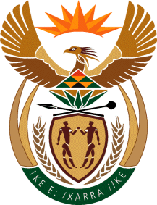
MINISTRY
SPORT AND RECREATION
REPUBLIC OF SOUTH AFRICA

Department of Sport and Recreation l Private Bag X896 l PRETORIA l 0001 l Regent Place l 66 Queen Street l Pretoria l 0001 l +27 (0)12 304 5158 l Fax: +27 (0)12 323 8426
Private Bag X9149 l Cape Town l 8000 l 2nd Floor Parliament Building l 120 Plain Street l CAPE TOWN l Tel: +27 21 469 5705 l Fax: +27 21 465 4402
www.srsa.gov.za
_____________________________________________________________________

NATIONAL ASSEMBLY

WRITTEN REPLY

QUESTION PAPER: No. 37 of 20 October 2017

DATE OF REPLY: 27 NOVEMBER 2017

3356. Mr. P G Moteka (EFF) asked the Minister of Sport and Recreation:
Whether he will continue with the Sports Focus Schools project that was started in 2015 and (b) what have been the achievements of the project to date? NW3522E

______________________________________________________________________
The Minister of Sport and Recreation

REPLY:

(a) Sport Focus Schools (SFS) are the pinnacle of the School Sport System and represent the first layer of our Sport Academy system as outlined in the South African Sport Academies Strategic Framework and Policy Guidelines. The SFS plays a central role in developing and nurturing talent identified by talent scouts in the national school sport leagues. It further ensures that each talented athlete has a development pathway in line with the National Federation’s Long-Term Participation Development Plan.

(b) We currently have 62 SFSes across all the 9 provinces catering for all 16 priority codes. We have about 67 learners under the Ministerial Bursary programme placed in some of the SFSes. Through the conditional grant framework, about 5% of the Sport Academies’ allocation is used to support SFSes in all provinces.

