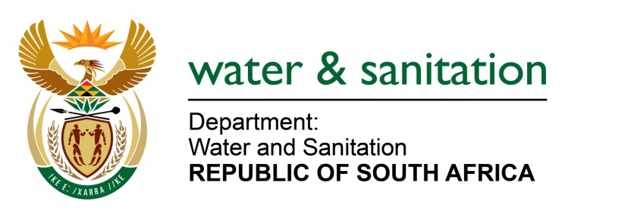

NATIONAL ASSEMBLY

FOR WRITTEN REPLY

QUESTION NO 3197

DATE OF PUBLICATION IN INTERNAL QUESTION PAPER: 20 OCTOBER 2017
(INTERNAL QUESTION PAPER NO. 37)
3197. Ms M S Khawula (EFF) to ask the Minister of Water and Sanitation:
With reference to her reply to question 1987 on 9 October 2017, how many litres of water are lost annually due to water leaks in each metropolitan municipality in each province? NW3521E
---00O00---
REPLY:
Refer to the table below for the litres of water lost annually due to water leaks in each metropolitan municipality.
Province | Metropolitan Municipality | Volume of water lost (Mega Litres/Annum) | Volume of water lost (Litres/Annum)
Western Cape | City of Cape Town | 42 177 | 42 177 000 000
Eastern Cape | Nelson Mandela Bay | 40 093 | 40 093 000 000
 | Buffalo City | 21 307 | 21 307 000 000
Gauteng | City of Johannesburg | 107 006 | 107 006 000 000
 | City of Tshwane | 70 423 | 70 423 000 000
 | Ekurhuleni | 59 321 | 59 321 000 000
Free State | Mangaung | 9 969 | 9 969 000 000
KwaZulu-Natal | eThekwini | 93 680 | 93 680 000 000
Total |  | 443 976 | 443 976 000 000

---00O00---

