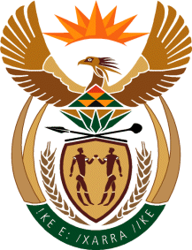

MINISTER IN THE PRESIDENCY: REPUBLIC OF SOUTH AFRICA
Private Bag X1000, Pretoria, 0001, Union Buildings, Government Avenue, PRETORIA
Tel: (012) 300 5200, Website: www.thepresidency.gov.za

NATIONAL ASSEMBLY

INTERNAL QUESTION PAPER

QUESTION NUMBER: 3197

3197. Dr M J Cardo (DA) to ask the Minister in The Presidency:

Were the Immigration Regulations that were introduced in 2014 assessed through the Socio-Economic Impact Assessment System in his Office to (a) ensure alignment with the National Development Plan and (b) reduce the risk of unintended consequences; if not, why not; if so, what are the relevant findings? NW3795E
REPLY:

The above Bill and Regulations have not been subjected to the Socio-Economic Impact Assessment (SEIAS). SEIAS was only introduced this year after approval by Cabinet in February 2015. The Department of Planning, Monitoring and Evaluation (DPME) conducted series of awareness and inductions between April and June 2015 for departments to institutionalise the SEIAS.

The implementation of SEIAS for developing or amending policies, legislations and regulations came into effect from 01 July 2015.

