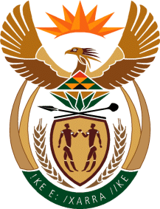

MINISTER IN THE PRESIDENCY: REPUBLIC OF SOUTH AFRICA
Private Bag X1000, Pretoria, 0001, Union Buildings, Government Avenue, PRETORIA
Tel: (012) 300 5200, Website: www.thepresidency.gov.za

NATIONAL ASSEMBLY

QUESTION FOR WRITTEN REPLY

QUESTION NUMBER: 3196

3196. Dr M J Cardo (DA) to ask the Minister in The Presidency:

Has the Private Security Industry Regulation Amendment Bill, which is currently awaiting the President’s assent, been assessed through the Socio-Economic Impact Assessment System in his Office to (a) ensure alignment with the National Development Plan and (b) reduce the risk of unintended consequences; if not, why not; if so, what are the relevant findings? NW3794E

REPLY:
The Private Security Industry Regulation Amendment Bill has not been subjected to the Socio-Economic Impact Assessment (SEIAS). SEIAS was only introduced this year after approval by Cabinet in February 2015. The Department of Planning, Monitoring and Evaluation (DPME) conducted a series of awareness and inductions between April and June 2015 for departments to institutionalise the SEIAS. About 136 officials in 33 departments were trained on SEIAS application.

The implementation of SEIAS for developing or amending policies, legislations and regulations came into effect from 01 July 2015.

