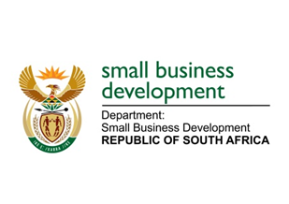
NATIONAL ASSEMBLY
QUESTION FOR WRITTEN REPLY
DUE IN PARLIAMENT: 30 SEPTEMBER 2022

“3193. Mrs N I Tarabella Marchesi (DA) to ask the Minister of Small Business Development:
(1) On what date did she attend the last meeting of any structure outside the Government in order to receive recommendations on the deployment of personnel in her department and/or entities reporting to her;
(2) whether any appointments to her department and/or entities reporting to her were discussed during her attendance at any private forum and/or external structures to the Government; if not, what is the position in this regard; if so, what (a) are the details of appointments that were discussed and recommendations received and (b) other Government matters were discussed during the last meeting of any such forum?” NW3913E

REPLY:

- The only meeting discussing appointments within the Department of Small Business Development (DSBD) that I attended within my role as Executive Authority of the DSBD was with the departmental officials duly appointed and authorised to engage on the appointment of personnel within the DSBD.
- All appointments within the Department of Small Business Development (DSBD) are in line with the relevant Public Service Regulations as published by the Department of Public Service and Administration. Appointments within the DSBD follows the processes and guidelines contained within the regulations. As such these appointments do not get discussed at forums or external structures that are not regulated by the Public Service Regulations.

STELLA NDABENI-ABRAHAMS
MINISTER: SMALL BUSINESS DEVELOPMENT

