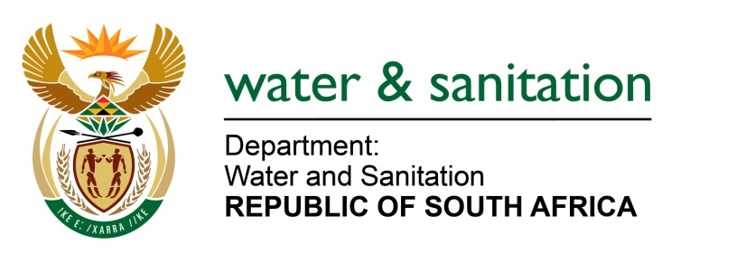

NATIONAL ASSEMBLY

FOR WRITTEN REPLY

QUESTION NO 3192

DATE OF PUBLICATION IN INTERNAL QUESTION PAPER: 20 OCTOBER 2017
(INTERNAL QUESTION PAPER NO. 37)
3192. Ms M Khawula (EFF) to ask the Minister of Water and Sanitation:
With reference to her reply to question 1987 on 9 October 2017, (a) in which municipality and (b) ward are most of the leaks located in (i) Gauteng and (ii) KwaZulu-Natal provinces? NW3516E
---00O00---
REPLY:

- Municipalities with most leaks are located in Gauteng and KwaZulu-Natal. The Department does not assess location of water leaks by wards system. Instead, Municipalities provide information on water leaks as per distribution/ reticulation systems in accordance with either the number of households, total reservoir supply area and/or systems operating pressure regime.

(b)(i) In Gauteng Province, the municipality with the most leaks is the Johannesburg Metropolitan Municipality.

(b)(ii) In KwaZulu-Natal Province, the municipality with most leaks is the EThekwini Metropolitan Municipality.

---00O00---

