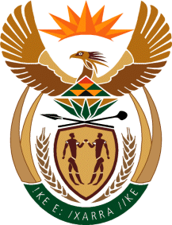

MINISTER IN THE PRESIDENCY: REPUBLIC OF SOUTH AFRICA
Private Bag X1000, Pretoria, 0001, Union Buildings, Government Avenue, PRETORIA
Tel: (012) 300 5200, Website: www.thepresidency.gov.za

NATIONAL ASSEMBLY
WRITTEN QUESTION FOR WRITTEN REPLY

QUESTION NUMBER: 3191
DATE OF PUBLICATIONS: 16 September 2022

3191. Mr M S Mabika (DA) to ask the Minister in The Presidency:
(1) On what date did he attend the last meeting of any structure outside the Government in order to receive recommendations on the deployment of personnel in his Office and/or entities reporting to him;
(2) whether any appointments to his Office and/or entities reporting to him were discussed during his attendance at any private forum and/or external structures to the Government; if not, what is the position in this regard; if so, what (a) are the details of appointments that were discussed and recommendations received and (b) other Government matters were discussed during the last meeting of any such forum? NW3909E

REPLY
- The Minister in the Presidency has never participated in any process wherein individuals were seconded or recommended for appointments in any Department and Entities under my Portfolio.
- No instructions were ever issued to any accounting officer to appoint an individual(s) to a position. All positions follow a due process as set out by the Public Service regulations for the recruitment, review and appointment of personnel in government departments and entities under my portfolio.
Thank You.

