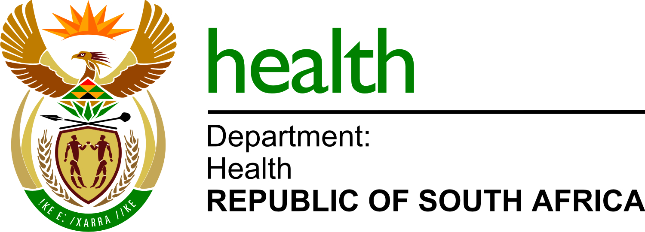

12 December 2018

Media statement by the Minister of Health Dr Aaron Motsoaledi
Placement of Interns and Community Service Health Professionals

The Minister of Health has today announced the placement of 9 797 newly qualified health professionals into Internship or Community Service posts throughout the country. These include Medical Interns, Community Service Doctors, Community Service Pharmacists, Professional Nurses, as well as Allied Health Professionals.
This announcement is a result of the sitting of the National Health Council which earlier this week had resolved to fill positions of more than 5 000 health care professionals and support staff in various categories other than Internship and Community Service.
The following categories will commence duty from the 1st of January 2019:
- 1 883 Medical Interns
- 1 465 Community Service Doctors
- 207 Community Service Dentists
- 3 483 Community Service Professional Nurses
- 766 Community Service Pharmacists
- 1 993 Community Service Allied Health Professionals.

Over the years, the Department had experienced serious hardships with the placement of these entry level Health workers into the Health workforce. These hardships manifested themselves with serious contestation from various categories of Health workers, especially Medical Interns, over their placement.
This contestation usually takes the form of debates in the media, where the Department and the Health professionals will be contradicting each other. We deem that an unhealthy state of affairs.
The National Health Council has therefore dealt with this problem in an endeavour to breaking with the past.
The Council further wishes to reiterate the fact that internship and community service are statutory functions for entry level health workers. It is not an option whether the State must place them or not, it is actually an obligation.
To avoid confusion that arose in the past, we wish to explain the positions:
Medical Interns:
These are Doctors who have just completed or are due to complete their medical studies this year. They will enter the workforce as the level of a two-year internship on 1st January 2019 – a total of 1 883 of them.
Community Service Doctors:
These are Doctors who have just completed their two-year Internship and have to enter a one-year Community Service – a total of 1 465 of them.
Community Service Dentists
These are Dentists who have just completed or are due to complete their Dentistry studies this year. Dentists do not do internship, they go straight from University into Community Service – a total of 207 of them.
Community Service Professional Nurses
These are Nurses who have completed or are due to complete their nursing studies at universities or colleges of Nursing this year. They enter the service at the level of Community Service – a total of 3 483 of them.
Community Service Pharmacists
These are Pharmacists who have just completed their one-year internship and have to enter the service as Community Service Pharmacists.
Allied Health or other categories of Community Service
These are Physiotherapists, Occupational Therapists, Radiotherapists, Speech Therapists, Audiologists, Environmental Health Practitioners, Radiographers, etc, who have completed or are due to complete their University studies this year. They are due for Community Service starting on 1st January 2018 – a total of 1 993 of them.

PROVINCIAL BREAKDOWN
Eastern Cape:
Medical Interns: 179
Community Service Doctors: 130
Community Service Dentists: 18
Community Service Pharmacists: 76
Community Service Nurses: 654
Allied Community Service: 186
Total: 1 243

Free State:
Medical Interns: 65
Community Service Doctors: 84
Community Service Dentists: 32
Community Service Pharmacists: 53
Community Service Nurses: 165
Allied Community Service: 156
Total: 555

Gauteng:
Medical Interns: 541
Community Service Doctors: 266
Community Service Dentists: 24
Community Service Pharmacists: 203
Community Service Nurses: 586
Allied Community Service: 527
Total: 2 147
KwaZulu Natal:
Medical Interns: 433
Community Service Doctors: 230
Community Service Dentists: 51
Community Service Pharmacists: 142
Community Service Nurses: 633
Allied Community Service: 379
Total: 1 868
Limpopo:
Medical Interns: 122
Community Service Doctors: 154
Community Service Dentists: 16
Community Service Pharmacists: 73
Community Service Nurses: 344
Allied Community Service: 145
Total: 854

Mpumalanga:
Medical Interns: 65
Community Service Doctors: 156
Community Service Dentists: 10
Community Service Pharmacists: 38
Community Service Nurses: 318
Allied Community Service: 176
Total: 763
North West:
Medical Interns: 110
Community Service Doctors: 157
Community Service Dentists: 24
Community Service Pharmacists: 80
Community Service Nurses: 431
Allied Community Service: 177
Total: 979
Northern Cape:
Medical Interns: 25
Community Service Doctors: 85
Community Service Dentists: 16
Community Service Pharmacists: 40
Community Service Nurses: 35
Allied Community Service: 133
Total: 334
Western Cape:
Medical Interns: 343
Community Service Doctors: 203
Community Service Dentists: 16
Community Service Pharmacists: 61
Community Service Nurses: 317
Allied Community Service: 114
Total: 1 054
Letters of appointment are being issued out starting this week. SMSes have already been sent to inform those affected people of their placements.
We appeal to them to contact the Province of their placement if they did not receive a letter of appointment by the last week of December 2018.
Alternatively, they may call or email the following:
- Call Centre: 087 012 5082
- ICSP@DHMIS.ORG
We wish them all the best in their new careers.

For media enquiries, please contact:

Mr Popo Maja, Ministerial Spokesperson, Popo.Maja@health.gov.za
Cell: 0725853219

