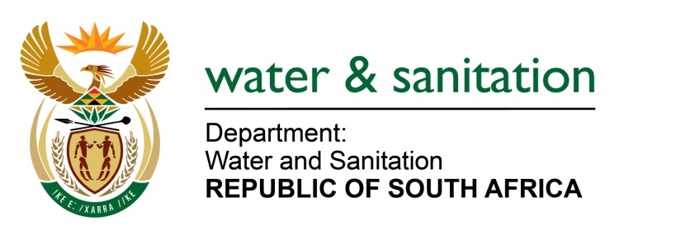

NATIONAL ASSEMBLY

FOR WRITTEN REPLY

QUESTION NO 319

DATE OF PUBLICATION IN INTERNAL QUESTION PAPER: 19 FEBRUARY 2016
(INTERNAL QUESTION PAPER NO. 2)

319. Mr R A Lees (DA) to ask the Minister of Water and Sanitation:

(1) Whether she is aware of the critical water shortages in Vryheid in the AbaQulusi Local Municipality in KwaZulu-Natal; if not, why not; if so, what steps is (a) she and (b) the specified municipality taking to address the critical water shortages in the specified municipality;

(2) (a) what were the levels of the (i) Klipfontein Dam, (ii) Grootgewacht Dam and (iii) Bloemveld Dam at (aa) 30 November 2015, (bb) 31 December 2015 and (cc) 31 January 2015 and (b) what are the levels in each case as at 15 February 2016;

(3) why has water from the Grootgewacht Dam not been released in time to feed the feeder dams;

(4) whether the water piped to the residents of Vryheid are safe to drink given that the feeder dam levels are so low; if not, why not; if so, what are the relevant details? NW328E
---00O00---

REPLY:

(1)(a) Yes, I am aware of the water challenges faced by the Vryheid (Abaqulisi Local Municipality (LM) within the Zululand District Municipality (DM).

(1)(b) My Department, after the 2014 drought declaration has allocated R39 693 million to the Zululand DM to address the drought to all its local municipalities which included Abaqulusi LM. The Zululand DM identified the following interventions to address the critical water shortages in the Abaqulusi LM:

- Drilling of new boreholes and refurbishment of existing boreholes
- Refurbishment of existing water schemes
- Springs protection and
- Water tankering

These interventions are currently underway to address the drought under the Abaqulusi LM and can be summarized as follows:

Drilling of new boreholes and refurbishment of existing boreholes: An existing borehole in Vryheid has been successfully refurbished and people are fetching water from this borehole during the day. Since the drought began, a number of new boreholes have been successfully drilled by the Zululand DM with the aim of augmenting the supply in the various rural water supply schemes. A total number of 7 new boreholes are planned specifically for the Abaqulusi LM and all have already been drilled and tested. The contractors have recently been appointed for equipping the boreholes with hand pumps and are currently undertaking this task.

Refurbishment of existing water schemes: Excellent progress has been made in regards to the refurbishment of existing water supply schemes; R17.5 million has been set aside by my Department for these much needed urgent refurbishments, of which the Zululand DM have expended at least R12.5 million. Four of the water schemes are nearly complete and the Odushwini Water Supply Scheme is at 20% completion, it is estimated to be completed by the end of May 2016.

Springs: Four springs have been identified in the Abaqulusi LM for protection and developing by the Zululand DM, using the DWS existing funding. The installation of 10 000l Jojo tanks and reticulation from the tanks to standpipes will be undertaken. The contractors were appointed in the late October 2015 and this work is being fast tracked to be completed by middle March 2016.

Water Tankering: The Abaqulusi LM owns two water tanker trucks and as such, struggles to service the vast areas of the Abaqulusi LM that are without formal water supply. DWS has approved the business plan and had budgeted R 4,123 million for the 7 tankers hired by the Zululand DM to supply water to severely affected areas within its 5 LMs. The Zululand DM confirms that at least two of their tankers were being sent to assist in parts of the Abaqulusi LM periodically.

Further to this, on 19 February 2016 the Zululand DM has allocated R3, 78 Million to Abaqulusi LM to deal with the current drought. The Department of Water and Sanitation, through its Branch: National Water Resource Infrastructure has also made 20 (5000 litres) JoJo tanks available to be used in Vryheid Town when the reticulated water is limited during the restricted period. The department has also set up the committee to monitor the drought situation in the Abaqulusi LM which is currently taking place weekly.

(2) Refer to the table below for the level of dam for the specified periods.

Name of Dam | 30 November 2015 | 31 December 2015 | 31 January 2015 | as at 15 February 2016
Klipfontein Dam | 22, 46%, | 20, 39% | 19, 88% | 21, 14%
Grootgewacht Dam | 96% | 96% | 96% | 92%
Bloemveld Dam | 0% | 0% | 0% | 0%

(3) The Grootgewacht Dam is reserved as a backup resource, when the other resources including the Klipfontein Dam are completely unavailable.

- Piped water for Vryheid is safe for human consumption as it goes through water treatment process to meet drinking standard prior to distribution.

---00O00---

