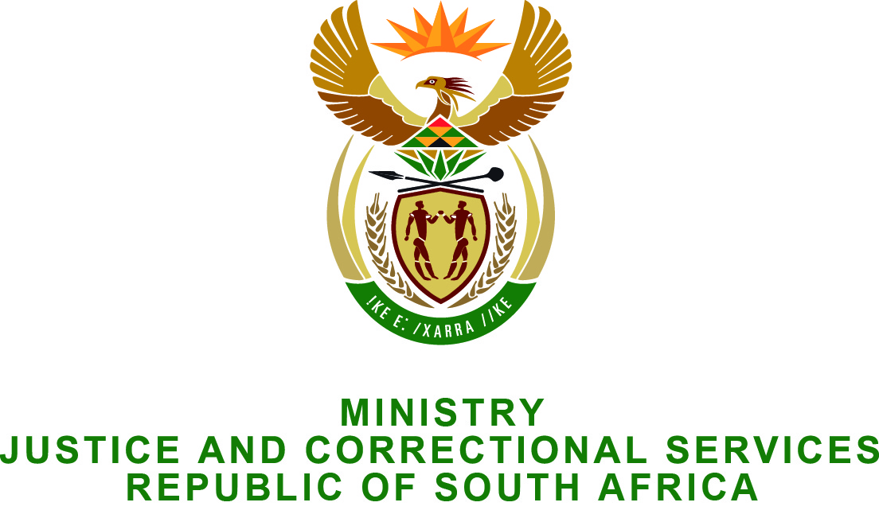

NATIONAL ASSEMBLY
QUESTION FOR WRITTEN REPLY
PARLIAMENTARY QUESTION NO: 3185
DATE OF QUESTION: 28 AUGUST 2015
DATE OF SUBMISSION: 11 SEPTEMBER 2015
Adv G Breytenbach (DA) to ask the Minister of Justice and Correctional Services:

What progress has been made in the (a) investigation and/or (b) prosecution in a certain matter (details furnished) which was formerly investigated by the Specialised Investigating Unit and which is currently with the Specialised Commercial Crime Unit in Pretoria? NW3783E

REPLY
- I wish to inform the Honourable Member that the investigation is at an advanced stage after suffering delays when both the lead investigator in the South African Police Services and prosecutor in the National Prosecuting Authority left the case in the middle before the investigation was completed.
- The investigation is anticipated to be finalised during the course of this year (2015).

