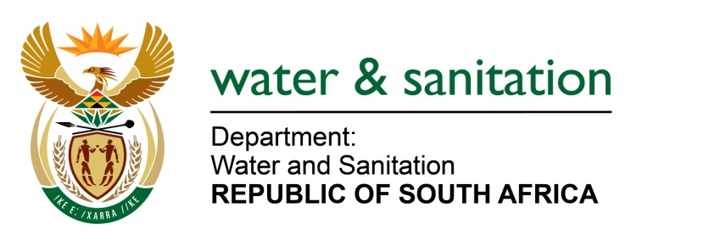

NATIONAL ASSEMBLY

FOR WRITTEN REPLY

QUESTION NO 3184

DATE OF PUBLICATION IN INTERNAL QUESTION PAPER: 20OCTOBER 2017
(INTERNAL QUESTION PAPER NO. 37)
3184. Mr L S Tlhaole (EFF) to ask the Minister of Water and Sanitation:
(1) What are the details including the ranks of service providers and/or contractors from which (a) her department and (b) the entities reporting to her procured services in the past five years;
(2) what (a) service was provided by each service provider and/or contractor and (b) amount was each service provider and/or contractor paid;
(3) (a) how many of these service providers are black-owned entities, (b) what contract was each of the black-owned service providers awarded and (c) how much was each black-owned service provider paid? NW3508E
---00O00---
REPLY:
- Below is a summary of the number of service providers awarded contracts within the Water Trading Entity for the past five years: A detailed list is attached as Annexure A.

Financial Year | Number of service providers awarded | Value of contracts awarded | Number of black owned service providers
2012/2013 | 84 | R 851 828 015,69 | 15
2013/2014 | 20 | R 4 934 499,54 | 4
2014/2015 | 56 | R 146 923 138,43 | 46
2015/2016 | 49 | R1 042 073 454,66 | 32
2016/2017 | 73 | R 2 577 015 536,13 | 53
TOTAL | 282 | R4 622 774 644,45 | 150
Below is a summary of the number of service providers awarded contracts in the Main Account for the past five years. A detailed list is attached as Annexure B.
FINANCIAL YEAR | Number of service providers awarded | Value of contracts awarded | Number of black owned service providers
2012-2013 | 27 | R751 398 911.58 | 2
2013-2014 | 31 | R1 102 770 352.49 | 8
2014-2015 | 30 | R1 549 933 060.69 | 11
2015-2016 | 31 | R1 833 330 569.24 | 12
2016-2017 | 64 | R649 265 895.74 | 16
TOTAL | 183 | R5 886 698 789.74 | 49
--00O00---

