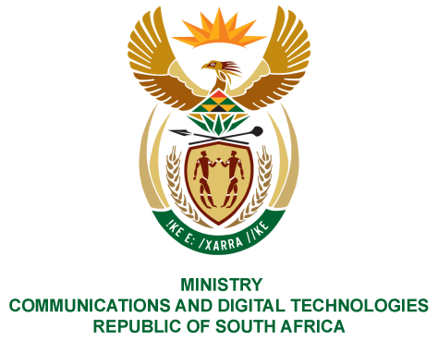
PARLIAMENT OF THE REPUBLIC OF SOUTH AFRICA
NATIONAL ASSEMBLY
WRITTEN REPLY

QUESTION NO: 318
DATE OF PUBLICATION: 19 February 2021
QUESTION PAPER NO: 02
Mr C MacKenzie (DA) to ask the Minister of Communications:
(a) What is the total number of bank accounts that the SA Post Office have and (b) will she furnish Mr C MacKenzie with the account balances as at (i) 31 March 2020, (ii) 30 June 2020, (iii) 30 September 2020 and (iv) 31 December 2020?
NW322E

REPLY:

I have been advised by the SAPO as follows:

- SAPO has fourteen (14) bank accounts for different operational requirements.
- The request for the bank account balances is noted. SAPO is however mindful that responses to parliamentary questions are public documents and given the sensitivities surrounding its finances, the bank account balances cannot be provided.

MS. STELLA NDABENI-ABRAHAMS, MP
MINISTER OF COMMUNICATIONS AND DIGITAL TECHNOLOGIES

